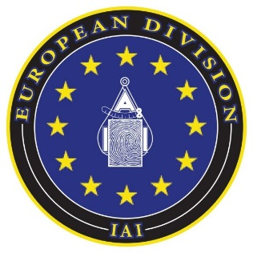

7th Conference of the European Division of the
International Association for Identification
10th -12th June 2024
Hotel Catalonia Plaza, Plaza Espanya, Barcelona, Spain


 Co-organised by Mossos D’Esquadra

Welcome to Barcelona and to the 7th conference for the European Division of the International Association for Identification in the 10th anniversary year of our organisation.

The Board of Directors been working with Mossos D’Esquadra to ensure that we have created an event that is interesting and engaging for all regardless of your discipline.

We have a wide range of speakers across multiple disciplines from research, academia and practice. As a European organisation we want to ensure that we provide an opportunity for members from many countries to attend a first-class training experience, to meet others who work many fields across the discipline and share experiences and practice. We really hope that you enjoy the presentations, and we look forward to the opportunity to network with you all in Barcelona.

Thank you to our sponsors who have made this conference possible and have sponsored the event. Please make sure that you visit all of the vendor stands during the breaks and learn about more about them.

Thank you to all of the presenters throughout the three days for your time and dedication to your discipline and forensic science as a whole.

A final thank you to Sergi Claveria and Roger Heredia who have worked so hard with the board to arrange this event, it would not have been possible without them.

EU IAI Board of Directors.

President | Jo Morrissey
Treasurer | Marcel de Puit
Board of Director | Aldo Mattei
Board of Director | Angelo Salici
Board of Director | Pedro Azevedo
Board of Director, Secretary | Ivan Birch
Board of Director | Anthony Laird
Board of Director | Ray Kane

GOLD SPONSORS
IDEMIA Public Security, a division of IDEMIA Group, is the premium provider of trusted biometric solutions that revolutionize public security and identity, travel and transport, and access control. Our solutions—designed using advanced security features and encryption technologies—enable our clients to build safer and fairer societies where people can live, interact, and move freely.
IDEMIA Public Security's Justice and Public Safety business line applies over 50 years of biometric expertise to empower global law enforcement agencies. With a dedicated team of almost 600 experts, we develop cutting-edge technologies—facial recognition, fingerprint matching, and investigative analytics—tailored for the unique needs of law enforcement agencies worldwide. Trusted by 85+ public customers, our solutions handle millions of records, and foster efficient policing with tools like livescan and mobile fingerprint devices.
Prioritizing fairness and accuracy, we collaborate closely with customers to create a safer, more secure world.
IDEMIA: your partner in preventing offenses, solving crimes, and protecting communities.


Our biometrics and identity solutions enable government agencies to solve crimes more efficiently, prevent fraud, secure national borders, or protect identities for various other applications.
We have more than 300 biometric deployments in 80 countries, leveraging strong biometric authentication and identification worldwide for customers at all government levels.
With more than 30 years of biometric technology expertise, Thales offers a comprehensive suite of technology products and services, helping governments and agencies worldwide keep the public safe and secure.

SILVER SPONSORS

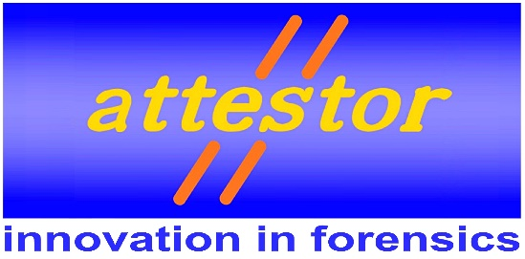

Attestor Forensics is a leading Germany-based company specialising in the development of innovative high-quality equipment to assist in forensic analysis and investigation. Our team collaborates closely with customers to meet their individual needs, providing a wide range of user-friendly equipment, including evidence development chambers, imaging systems and forensics light sources.
Attestor products are internationally recognised and tailored specifically for customers who require enhanced efficiency without compromising on quality results and traceability.
For ISO accredited laboratories, reproducibility and documentation is extremely important, so many of our products automatically record process information via our datalogger system.



The eyesCloud3D platform is transforming the forensic field by simplifying the generation of 3D scenarios. Using common devices such as mobile phones or other devices with a camera, it allows crime scenarios to be recreated quickly and accurately.
Its ease of use and the functionalities it contains make the work of forensic scientists more efficient by enabling import and export in different formats. In addition, it offers a unique interactive experience with more than 60 tools designed to interact with the generated models, allowing detailed analysis to be performed with ease and accuracy.

BRONZE SPONSORS


Founded in 1978 following successful development of ESDA, a unique electrostatic apparatus used to highlight indented writing in documents, Foster + Freeman are innovators in the design and manufacture of systems for the examination of questioned documents, latent fingerprints, trace evidence, and shoe prints used by specialist forensic laboratories world-wide. With offices in the UK, USA, Europe, and a global network of agents and distributors, Foster + Freeman are able to provide customers with a high level of technical support, installation and training. Our equipment is exported to over 160 countries.

Indra is one of the leading global technology and consulting companies, world leader in engineering technology for aerospace, defense, security and mobility business with a business model, based on a comprehensive range of proprietary products, with a high-value end-to-end focus and a high degree of innovation.
Special Thanks to Our Sponsors

Without the valued contribution of our sponsors it would not be possible to put on a conference of such high quality. Their contribution has enabled the Board of Directors to select a quality venue, attract top class speakers and also ensure your conference experience is provided at an affordable cost. With heartfelt thanks to our generous benefactors.
CONFERENCE PARTNERS
We would like to pass on our thanks and appreciation to our conference partners Mossos D’Esquadra. They are our hosts and have been an integral part of the organisation of this event. Without their help and support we would not have been able to organise this event for you.

7th Conference of the European Division of the International Association for Identification
10th -12th June 2024
Hotel Catalonia Plaza, Plaza Espanya, Barcelona, Spain

Programme for Monday 10th June
0830 | Registration begins
0900 - 1030 | INTERPOL DVI/ DVI Commanders role  Charles Lamens, DVI Commander, Interpol
1030 - 1100 | Break
1100 – 1230 | The role of fingerprints in Disaster Victim Identification  John Riemen. Lead Specialist in Biometrics, Dutch Police
1230 - 1330 | LUNCH BREAK
1330 - 1445 | The uses of craniofacial identification methods in DVI – challenges and opportunities  Caroline Wilkinson, Director of the Forensic Research Institute (FORRI) at Liverpool John Moores University
1445 - 1500 | Break
1500 - 1550 | Case Study  Sergio Castro Martinez, Chief Inspector, General Commissariat of Scientific Police
1600 | Close of Day
Monday Social event
Visit to the Sagrada Familia (transport and entrance included) You need to have registered for this trip.
The transport leaves hotel at 1600 so please be there on time.
Programme for Tuesday 11th June
0800 | Registration Opens
0900 - 0930 | Presidents Welcome  Joanne Morrissey, EUIAI President  Welcome from Mossos D’Esquadra
0930 - 1015 | Keynote Speaker  Domingo Villarreal, President of the International Association for Identification
1015 - 1045 | Migrant Disaster Victim Identification (MDVI): COST Action  Professor Caroline Wilkinson, Liverpool John Moores University, UK
1045 - 1115 | Chemical Profiling Fingerprints and the Bigger Picture.  Marcel de Puit, Netherlands Forensic Institute
1115 - 1145 | Break
1145 - 1215 | Investigating a Religious Cult Double Homicide  Alison Hutchens, Tucson Police Department, Arizona, USA
1215 - 1300 | EUIAI Membership meeting - AGM  All members to attend
1300 - 1400 | LUNCH BREAK
1400-1430 | Visualising the underworld: A UK fingermark enhancement laboratory collaborative project  Zoe Cadwell, University of Portsmouth and Hampshire Police, UK
1430-1500 | Unlocking Forensic Secrets: Enhancing Fingermark Quality with Immunolabeling  Annemieke van Dam - University of Amsterdam, Amsterdam UMC & Amsterdam University of Applied Sciences - Forensic Science
1500 - 1530 | Fingermark Development on 'Leather': New insights for a diverse and evolving surface  Leisa Nichols-Drew , De Montfort University
1530 – 1600 | Break
1600 - 1630 | Establishing the Probative Value of Gait Analysis Evidence: Principal Components and Bayesian Networks  Ivan Birch, FGA Services, UK
1630 - 1700 | Accelerating Forensic Fingerprint Identification: Strategies and Innovations Stéphane Caillebotte, Senior Law Enforcement Innovation Manager, IDEMIA Identity and Security
1700 | Close of Day
1900 Conference Dinner at Mussol Arenas, Gran via Corts Catalanes

Programme for Wednesday 12th June
0830 - 0900 | Addressing professional matters in the fingerprint profession: the European perspective  Aldo Mattei, RaCIS Carabinieri
0900 - 0930 | Development of conductive fingermarks for forensic applications  Dr. Laura Vera Stimpson, Canterbury Christchurch University, UK
0930 - 1000 | Rehabilitation of Latent Fingerprint Unit at DC DFS  Angelic Rountree and Alice White, DC Department of Forensic Science
1000 - 1030 | Enhancing training initiatives: Establishing an internal training program for facial examination  Sara Gotske, Danish National ID Centre
1030 - 1100 | Break
1100 - 1130 | Hotel Case, a drug facilitated sexual assault  Cristina Herrero Lopez, Mossos D’Esquadra
1130 - 1200 | Let's Make Some Noise About Noise: The impact of variability in forensic examination.  Caroline Gibb, University of Twente
1200 - 1230 | Something in the air tonight, A case study  Ray Kane
1230 - 1330 | LUNCH BREAK
1330-1400 | Dansyl fluorophore functionalized hierarchically structured mesoporous silica nanoparticlaes as novel latent fingerprint development agents.  Nicholas Ross, University of Leicester
1400 - 1430 | Cinderella Analysis: Barefoot and foot-in-shoe analysis in a forensic context  Nadia Asgeirdottir, FGA Services, UK
1430- 1500 | DigiAmmo: an EU funded ENFSI project how to exchange and assess 3D Forensic Ballistic Data.  Angelo Salici, RaCIS Carabinieri
1500 - 1530 | Break
1530 – 1600 | The effect of additional wrapping of pieces of evidence after packaging and transport on latent fingermarks  Dieter Pater, Amsterdam University of Applied Sciences
1600 - 1630 | Generation of 3D models for investigation through photogrammetry  E-Capture research and development SL
1630 | Closing remarks

Masterclass Presenters
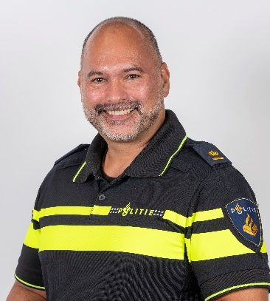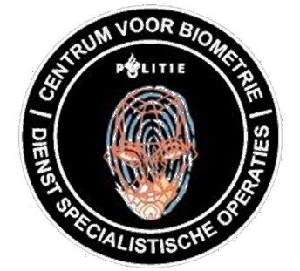

John A.J.M. Riemen is lead specialist to the Dutch Police and is the manager and custodian of the national criminal ABIS. He oversees the Center for Biometrics as part of the National Forensic Service Centre of the national Police and nationally responsible for the Fingerprint and Face identifications. He serves as the expert witness in court for these fields and is the strategic advisor to the office of the national Police Commissioner.
He has experience in the use of forensic fingerprint technologies, face recognition, disaster victim identification, identity management, identity fraud and process design in the field of biometrics. Mr Riemen is for more than 38 years active in law enforcement and for more than 22 years in forensic science.
He currently serves as a member of the IDEMIA Public Security Executive Users Board as international users representative.
He is the chosen chair of the Friction Ridge and Face Comparison sub-working group of the Interpol Disaster Victim Identification Working group.
He is guest lecturer at the University of Amsterdam and the national Police Academy.

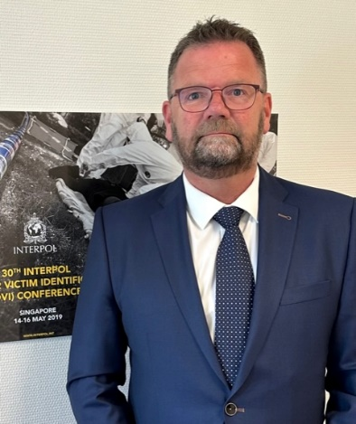
Charles Lamens is a Dutch police officer with 40 years of experience in various roles within the police force. He started his career as a street police officer and spent the last 15 years managing the police deployment in several cities in the Netherlands. In addition to this, Charles has been working in the field of disaster victim identification (DVI) for over 20 years. He began as a family liaison officer and served as the commander of the Dutch DVI team for the last 8 years. During his DVI career, he has been involved in the identification of victims of numerous disasters, including the Tsunami and several plane crashes. During the MH17 disaster, he served as deputy commander. Since May 2023, Charles has been appointed as Coordinator of the INTERPOL DVI unit in Lyon, France. In this role, he is responsible for coordinating activities and missions between various DVI teams, as well as overseeing communication, training, and other responsibilities related to the unit's work.

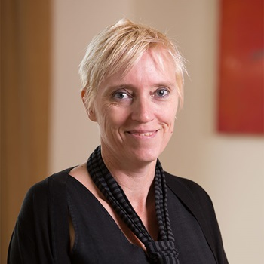
Caroline WIlkinson is Professor of Craniofacial Identification and Director of the Forensic Research Institute (FORRI) at Liverpool John Moores University. She is a chartered forensic anthropologist Level I (craniofacial specialism) by the Royal Anthropological Institute (RAI) and is an experienced forensic practitioner.
Caroline is currently Chair of the EU-funded COST Action for Migrant Disaster Victim Identification, a consortium created to enhance the identification of people who die trying to reach Europe from war torn or socioeconomically disrupted countries. These MDVI efforts received a Times Higher Education Award 2023 for Research Project of the Year; Arts, Humanities and Social Sciences.
Caroline is also Director of Face Lab, a research group within FORRI that carries out forensic/archaeological research and consultancy work including craniofacial analysis, facial depiction and forensic art. Craniofacial analysis involves the depiction and identification of unknown bodies for forensic investigation or historical figures for archaeological interpretation. Face Lab research relates to facial identification, craniofacial reconstruction, preserved bodies and facial animation. Face Lab has depicted the faces of King Richard III, Robert the Bruce, Ramesses II and Cleopatra.
Caroline is Fellow of the RAI, the Royal Society of Edinburgh (RSE), the Anatomical Society and the Royal Photographic Society. She received the 2016 Combined Royal Colleges Medal for excellence in clinical imaging and has appeared in multiple television series, including Meet the Ancestors (BBC), History Cold Case (BBC), Expert Witness (C4), Real crime (C5), Royal Institution Christmas Lectures 2022 (BBC) and Secrets of the Dead (PBS).
Poster Presentations
Migrant Disaster Victim Identification
Dr Maria Castaneyra-Ruiz and Prof Caroline Wilkinson
This poster describes the COST Migrant DVI Action and includes a QR code for application to a working group. https://www.cost.eu/actions/CA22106/

Towards the development of a portable biosensor for fingermark profiling.
Maria Dede, Amsterdam UMC
During crime scene investigations, fingermarks are valuable and non-transferable pieces of evidence for the evaluation of source and/or activity level propositions. However, individualization through the ridge pattern analysis and comparison is not always possible, since the fingermarks may be smudged, distorted and/or no reference fingerprint is present in the fingerprint database. Any additional information that can be retrieved from a fingermark can be used to provide new leads, exclude from, or restrict the list of possible suspects during the investigative phase.
Beyond the ridge pattern, a fingermark contains a complex mixture of endogenous and exogenous components. The chemical analysis of a fingermark’s composition can reveal donor profiling information such as, age, sex, drug abuse, blood type, and lifestyle. Such chemical profiling is not only relevant for identification purposes when standard methods fail, but also for evidential purposes as this profile can be utilized in court to link a donor to certain activities or to prove or disprove testimonies.
Here we present the first steps towards the development of a novel tool to create the chemical profile of a fingermark. Micro-ring resonators are implemented for the detection of relevant biomarkers in a miniaturized, portable, sensitive, and highly specific system that relies on antibody-biomarker interactions. A first toolkit should allow the extraction of three types of information from a fingermark namely, the sex of the donor, the blood type of the donor, and the time since deposition of the mark. We will present an overview of the project, including our most relevant findings towards the development of such toolkit.

Solvent Replacement Alternatives for Fingermark Visualisation in the Indandione Process
Grace Cornell, Defence Science and Technology Laboratories (Dstl)
The supply of 3M’s NovecTM HFE 7100 will be ceasing by the end of 2025 due to a decision by the manufacturer based on its detrimental environmental impact. Additionally, the family of substances that HFE 7100 falls into (per- and polyfluoroalkyl substances (PFAS)) are proposed for restriction under the Registration, Evaluation, Authorisation and Restriction of Chemicals (REACH) regulation. These restrictions to supply could have a huge impact on fingermark visualisation capability in the United Kingdom as HFE 7100 is the carrier solvent in the main amino acid reagents recommended in the Fingermark Visualisation Manual for porous and semi-porous surfaces. The Defence Science and Technology Laboratory (Dstl) have identified chemically equivalent replacements for 3M’s NovecTM HFE 7100 to provide a short-term resolution. Research into both flammable and non-flammable non-PFAS alternatives is also underway. Studies have been executed to contend with ink diffusion and the safe use of flammable solvents for the process. This presentation will outline the promising options being taken forward for further exploration.
© Crown Copyright 2024, Dstl. This information is licensed under the terms of the Open Government Licence v3.0 except where otherwise stated. To view this licence, visit http://www.nationalarchives.gov.uk/doc/open-government-licence/version/3

