Appendix A. Questionnaire T0 (translated paper version)

Fawaka questionnaire
In the coming weeks you will be working on a program about sustainable entrepreneurship by Fawaka Ondernemersschool. We would like to know what you learn from the program and what you think about it. That's why we are doing research.
You can give your own opinion on all questions. There are no right or wrong answers. Only the researchers see your answers. With this they give tips to Fawaka to make the program better. So you can help with that. Good luck!

My nickname is ……………………………………

I'm in group ……..

I'm a...
- girl
- boy
- other
- I don't want to say

Do you know someone who owns their own business?
- Yes
- No
- I do not know

Have you ever had lessons about starting a business before?
- Yes
- No

Now you get a number of statements. Please indicate whether you agree or not

 |  |  |  |  | 
I know a lot about how to start a business
I know what sustainability means
I can handle money well
I know a lot about where items in the shop come from
I think it is important to take good care of nature
I think it is important to take good care of the people around me
I think it's important to know where my food comes from
I think it's important to know what happens to my things after I throw them away
I think companies can help solve big problems in the world

The following statements are about yourself. Please indicate whether you agree or not

I keep working, even when it's hard
I am confident that everything will work out
I know what I'm good at
I like it when I can solve a difficult problem by working hard
I often have ideas to solve problems
I can present my ideas well
I work well with other children

The following statements are about the future. Please indicate whether you agree or not
I think it would be nice to have my own company in the future
Later when I start working, I want to earn as much money as possible
Later when I start working, I want to help to solve problems in the world
In the future, I want to work in a company that helps solve big problems in the world
In the future, I want to have my own company that helps solve big problems in the world

Would you like to tell us something about this questionnaire? Then write that down here.
________________________________________________________________
________________________________________________________________
________________________________________________________________
________________________________________________________________
Thank you for filling in!

Appendix B. Questionnaire T1 (translated paper version)
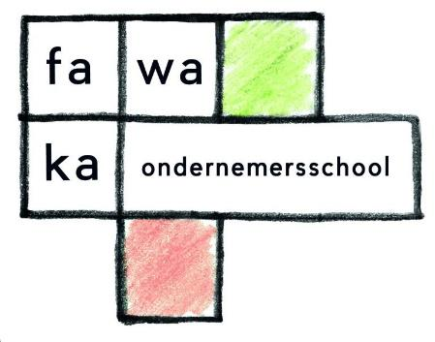


Fawaka questionnaire
Over the past few weeks you have participated in a program about sustainable entrepreneurship by Fawaka Ondernemersschool. We would like to know what you have learned from the program and what you think of it. You can give your own opinion on all questions. There are no right or wrong answers. Only the researchers see your answers. With this they give tips to Fawaka to make the program better. So you can help with that. Good luck!

My nickname is ……………………………………

I'm in group ……..

I'm a...
- girl
- boy
- other
- I don't want to say

Now you get a number of statements. Please indicate whether you agree or not
I know a lot about how to start a business
I know what sustainability means
I am good with money
I know a lot about where items in the shop come from
I think it is important to take good care of nature
I think it is important to take good care of the people around me
I think it's important to know where my food comes from
I think it's important to know what happens to my things after I throw them away
I think companies can help solve big problems in the world

The following statements are about yourself. Please indicate whether you agree or not
I keep working, even when it's hard
I am confident that everything will work out
I know what I'm good at
I like it when I can solve a difficult problem by working hard
I often have ideas to solve problems
I can present my ideas well
I work well with other children

The following questions are about the future. Please indicate whether you agree or not

I think it would be nice to have my own company in the future
Later when I start working, I want to earn as much money as possible
Later when I start working, I want to help to solve big problems in the world
In the future, I want to work in a company that helps solve big problems in the world
In the future, I want to have my own company that helps solve big problems in the world

The following questions are about what you think of Fawaka's entrepreneurship lessons

I learned new things in the entrepreneurship lessons
I had fun during the entrepreneurship lessons
I am proud of what we have achieved
I know better what I'm good at because of the entrepreneurship lessons

I give the entrepreneurship lessons the report mark ……… (between 1 and 10)

Did you talk about the entrepreneurship lessons at home?
- Yes
- No

Please write down one thing you learned from the entrepreneurship lessons.
_________________________________________________________
_________________________________________________________
_________________________________________________________
_________________________________________________________
_________________________________________________________
Would you like to tell us more about the entrepreneurship lessons or about this questionnaire? Then write that down here.
____________________________________________________________
____________________________________________________________
____________________________________________________________
____________________________________________________________
____________________________________________________________

Thank you for filling in!

