Social Comparison in Learning Analytics Dashboard to support motivation and academic achievement
Supplemental material

1 Dashboard

1.1 Grade-prediction algorithm
The prediction is made with a Bayesian Ridge Regression with the implementation proposed in Tipping (2001), with hyperpa- rameter 𝛼₁ = 𝛼₂ = 𝜆₁ = 𝜆₂ = 10⁻⁶ (in particular, the BayesianRidge function in the Scikit-Learn package in Python was used; Pedregosa et al., 2011). The Bayesian regressions have the advantage that they provide information about the uncertainty of the prediction. Both predicted mean and uncertainty are used to draw the normal distribution. In addition, this method was chosen over an algorithm proposed by Meier and colleagues (Meier et al., 2016). Meier’s algorithm was designed to timely estimate a student’s final grade based on the grades of previous years’ students. It resembles a K-nearest neighbors algorithm and also provides uncertainty of the prediction. Although this algorithm was argued to be most appropriate for this type of data, the Bayesian regression resulted in lower root-mean-square error for timed predictions. Figure S1 shows the prediction error of the two algorithms trained on the previous year’s grades with final grades as target values and tested on the treatment group’s final grades, which validate the choice for the Bayesian regression. Note that the confidence threshold included in Meier’s algorithm was left out because the intervention design required that subjects be able to see their predicted final grade at all stages of the course.
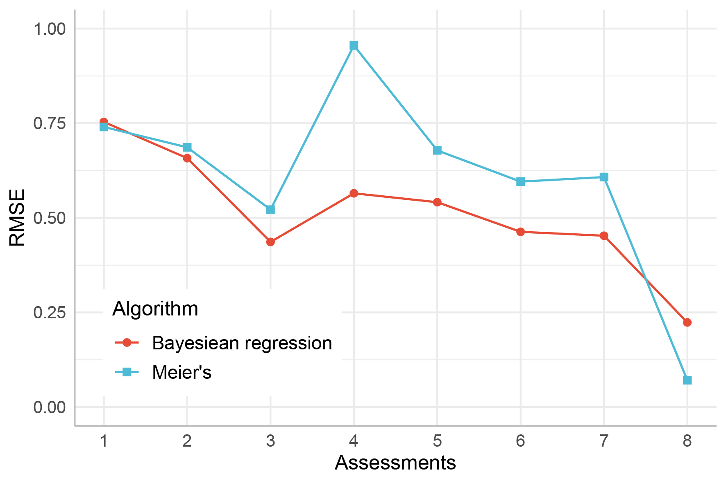
Figure S1. Root-Mean-Square Error (RMSE) of the Bayesian regression algorithm used to predict final grades (in red) compared to an algorithm proposed by Meier et al. (2016; in blue). The algorithms were trained on previous year grades and tested on the average grades of the treatment group in experiment 1. In the beginning of the intervention the average grade consists only of one assessment. With time, more assessments are graded and their weighted averages form the average grade. The x-axis represents the number of assessments graded and can be viewed as a time axis. The algorithm of Meier and colleagues was set up with first radius r1 = 14, which was the value that gave the lowest RMSE. For the sake of interpretation on the side of the user, the data was not standardised. Using standardising data may have improved precision of the algorithm but would then not have returned a prediction in the form of a grade, which was the purpose of the dashboard.

2 Experiment 1

2.1 Analysis
To measure the effect of the intervention through time, we compared the standardised grades obtained on different instances of the same type of assessment. There were two homework assignments (formative assessments) and two midterm exams (summative assessments). We also evaluated the effect of the LAD on quiz and essay grades, two isolated assignments given at the beginning and the end of the course, respectively. The course included two additional assignments which generated updates in the LAD, but they were not included as outcome variables in the analysis because they were group assignments.
We used linear mixed-effect analysis to evaluate the effect of the LAD on homeworks and midterms, with ‘group’, ‘time’ and ‘group’ x ’time’ as fixed effects and subject number as random intercept. The effect on the quiz and essay was tested with linear regressions with ‘group’ as fixed effect (See Table S1 for the details of the results).
In Author (20xx), we reported a main effect of LAD exposure on overall homework grades (β = 0.60, S.E. = 0.28, t = 2.20, p = 0.03), indicating that treatment subjects performed on average 11% better than control subjects in homework assignments. The analysis was performed by testing the fixed effects separately. In the current study however, we tested the full model. By including the interaction effect, the main effect of ‘group’ on homework grades was not significant anymore. Our analysis in the current study indicates that the two groups performed similarly in both homework and midterm assignments (Table S1). In midterm assignments, they achieved higher grades in the second midterm than in the first. Figure S2 shows a trend suggesting that treatment subjects outperform control subjects with time, both in homework assignments (middle pane) and in the midterm exams (right pane). The trend was, however, not significant.

Table S1. Effect of the LAD in experiment 1 on different measures of achievement.
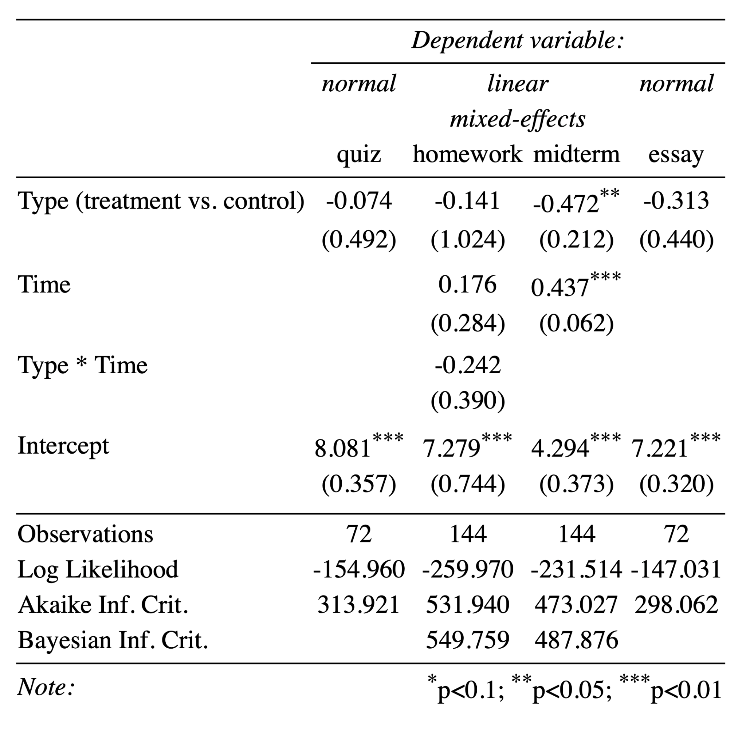

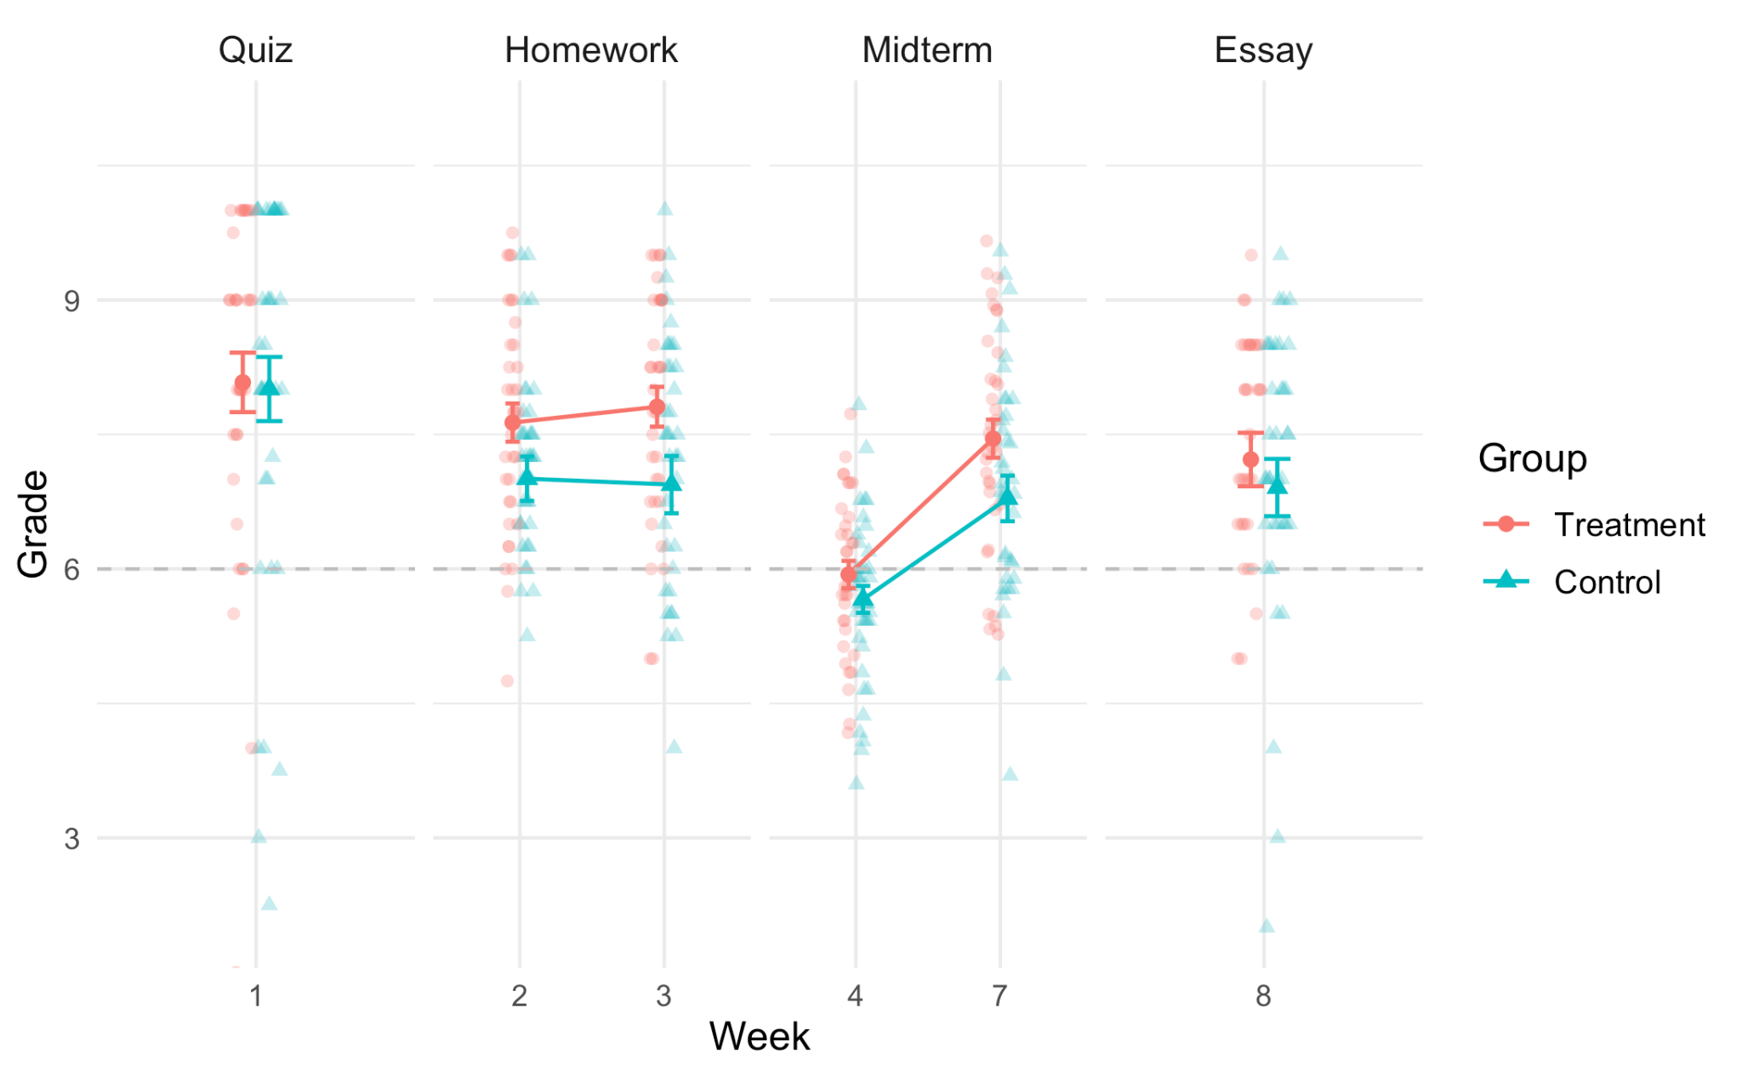
Figure S2. Mean grade for all individual assignments in experiment 1, grouped by type of assignment. Standard error is represented by the bars. The y-axis represents the week in the course when the assignment was done. The x-axis represents the grade obtained (0-10). The horizontal dashed line shows the passing grade

Table S2. Results of experiment 1 for intrinsic and extrinsic motivation (MSLQ) and metacognitive knowledge and control (MAI)
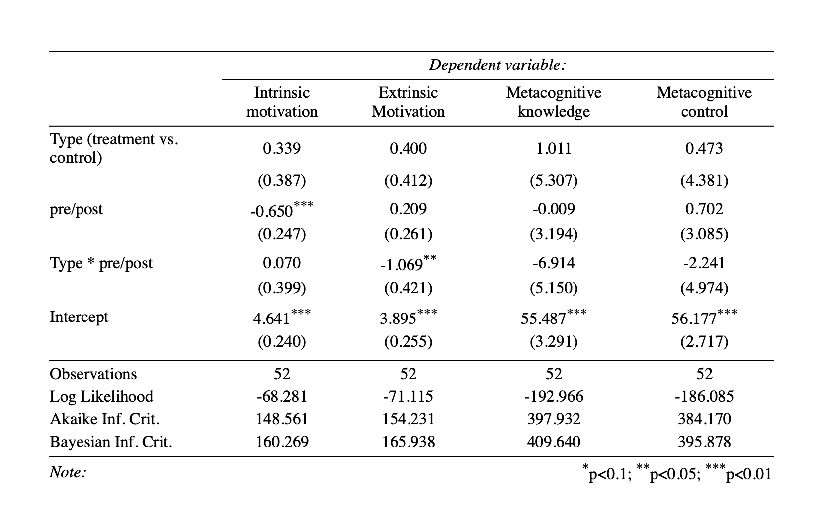

LAD usage
LAD usage in the treatment group varied greatly from student to student, ranging from 1 to 21 logins over the course of the experiment. On average, they consulted the LAD 9.26 times (sd = 5.86). LAD usage did not correlate with achievement or any self-reported measure.

3 Experiment 2

3.1 Pre-registered analysis
The individual assignments were grouped in two types of assignments: quiz assignments and computer practicums. All assignments in one type were of the same format and are therefore comparable. To test the effect of the intervention on assignments we performed two linear mixed-effect models, with quiz grades and computer practicum grades, respectively, as outcome variables. In both models, ‘group’ (treatment vs. control), ‘time’ (in what week was the assignment done) and the interaction of ‘group’ and ‘time’ were used as fixed effects. Subject numbers were used as a random intercept. Quiz grades did not differ significantly between the two groups, but treatment subjects performed better overall than control subjects in computer practicums. Achievement did not tend to increase with time for either type of assignments (Figure S3; Table S3). The results self-reported measures including metacognitive knowledge and control (MAI), and intrinsic motivation and metacognitive self-regulation (MSLQ) can be found in Table S4

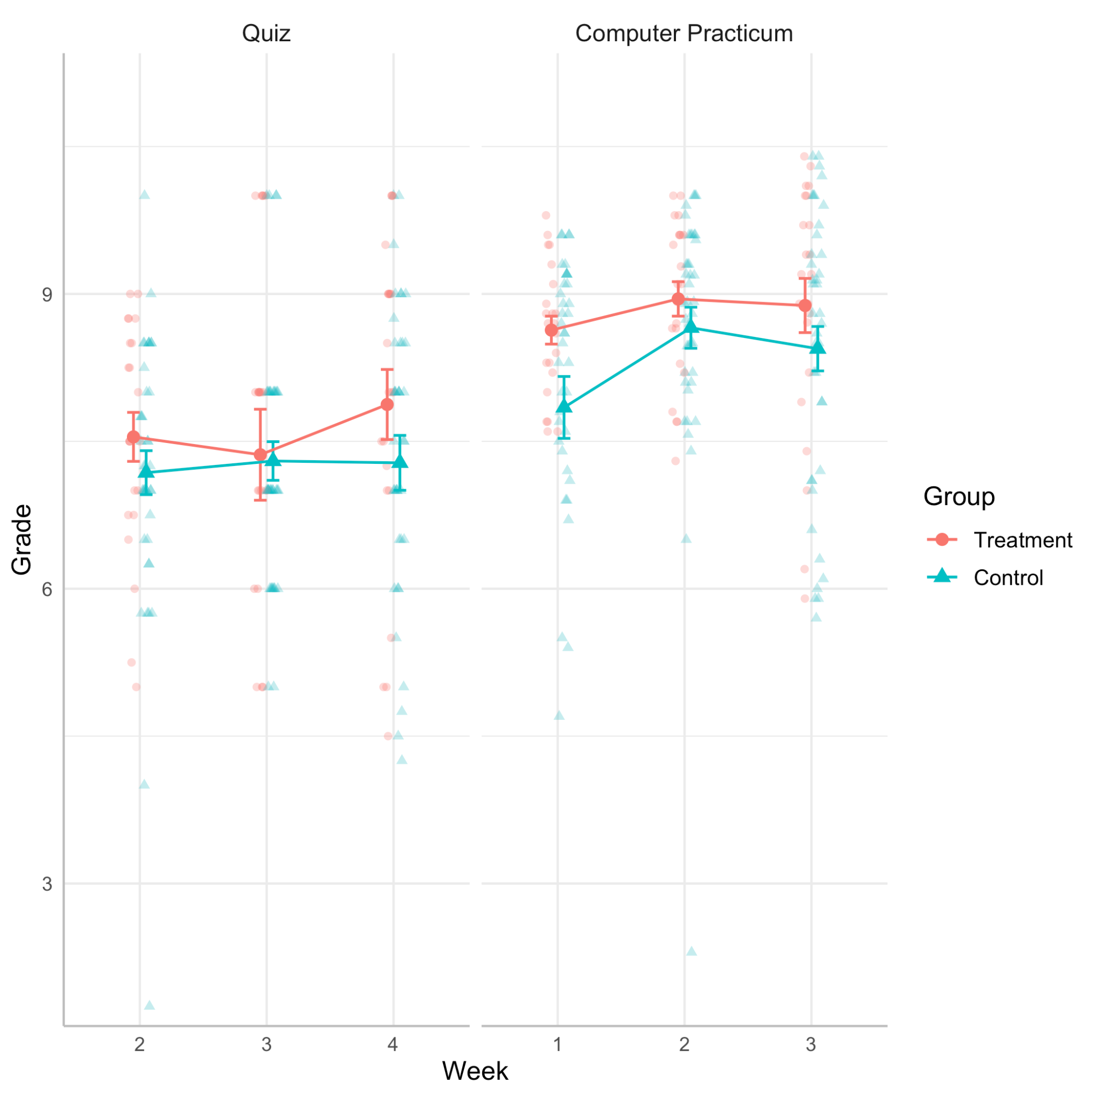Figure S3. Mean grades obtained for individual assignments during experiment 2 grouped by assignment type for both treatment (red, rounded dot) and control group (blue, triangle dot).
Table S3. Results of experiment 2 for different measures of achievement
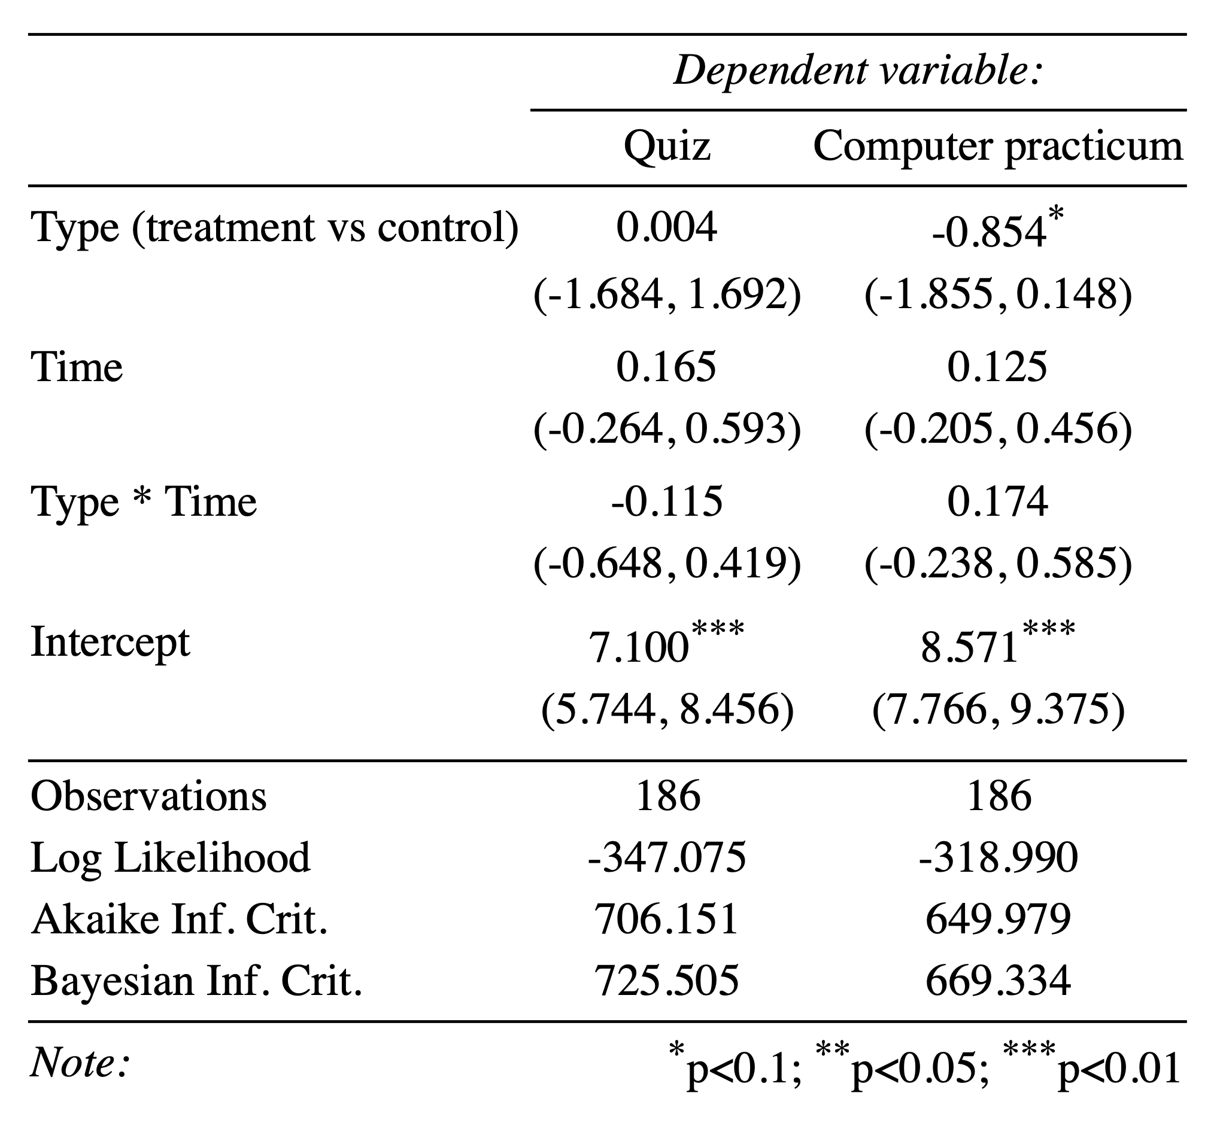

Table S4. Results of experiment 2 for different questionnaire scales
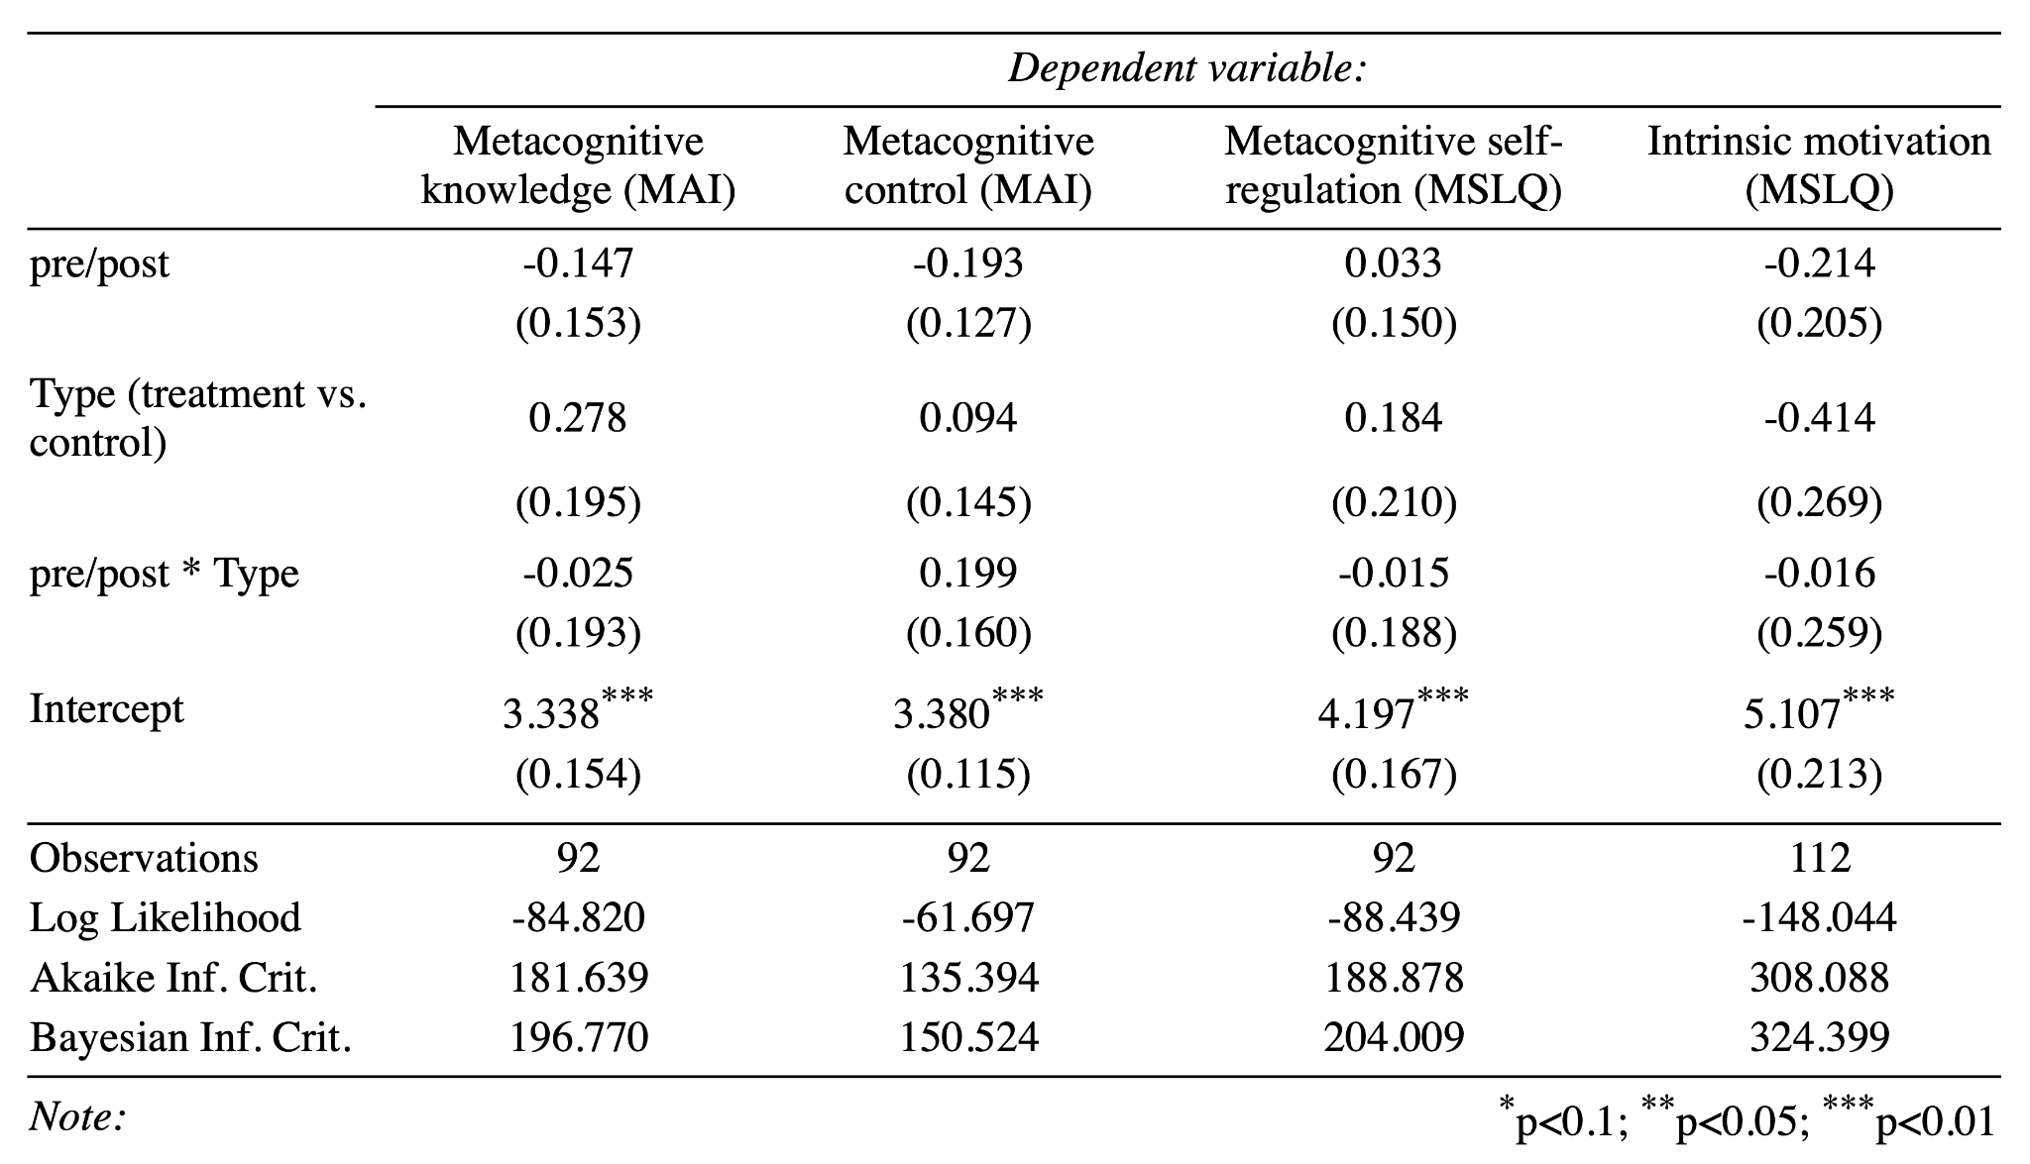

LAD usage
As in experiment 1, LAD usage in the treatment group varied vastly from student to student, ranging from 1 to 51 logins over the course of the experiment. On average, they consulted the LAD 10.56 times (sd = 14.61). As in experiment 1, LAD usage did not correlate with achievement or any self-reported measure.

3.2 Exploratory analysis - ASRS
In addition to the pre-registered analysis we also performed exploratory analysis on the effect of the intervention on motivation as operationalised by the Academic Self-Regulation Survey (ASRS; Vansteenkiste et al., 2009, 2005) as alternative assessments of motivation. The ASRS is rooted in Self-Determination theory , proposing that motivation be placed on a spectrum from external (e.g., ‘I’m studying because I’m supposed to do so’), to introjected (e.g., ‘… because I want others to think I’m smart’), to identified (e.g., ‘… because this is personally important to me’), to intrinsic (e.g., ‘… because I enjoy doing it’).
We first ran linear mixed-models for each scale of the ASRS independently, with ‘time’ (measure at the beginning or end of the experiment), ‘type’ and the interaction of ‘time’ x ‘type as fixed effect. Subject numbers were used as random intercepts. We found that treatment subjects overall had higher introjected motivation. We did not find any significant interaction effect, indicating that there was no difference between the two groups in how motivation changed in the course.
We next investigated whether subjects shift their motivation from more extrinsic to more intrinsic, and vice-versa. To do so, we labeled each scale with a number from 1 to 4 (from more extrinsic to more intrinsic). For each subject and for both pre- and post-measures, we identified the scale that had the highest score and included the associated number in the ‘motivation shift’ variable. For example, a student scoring highest on introjected motivation at the beginning of the course and then highest on intrinsic motivation at the end would have ‘2’ and ‘4’ as values in ‘motivation shift’. We then ran another linear mixed-effect model with the same fixed and random effects as above and with ‘motivation shift’ as outcome variable. There was no main effect and significant interaction effect indicating that subjects did not shift to more or less intrinsic throughout the experiment (Table S5).

Table S5. Results of experiment 2 for different scales of the ASRS and on the shift from one scale to another.
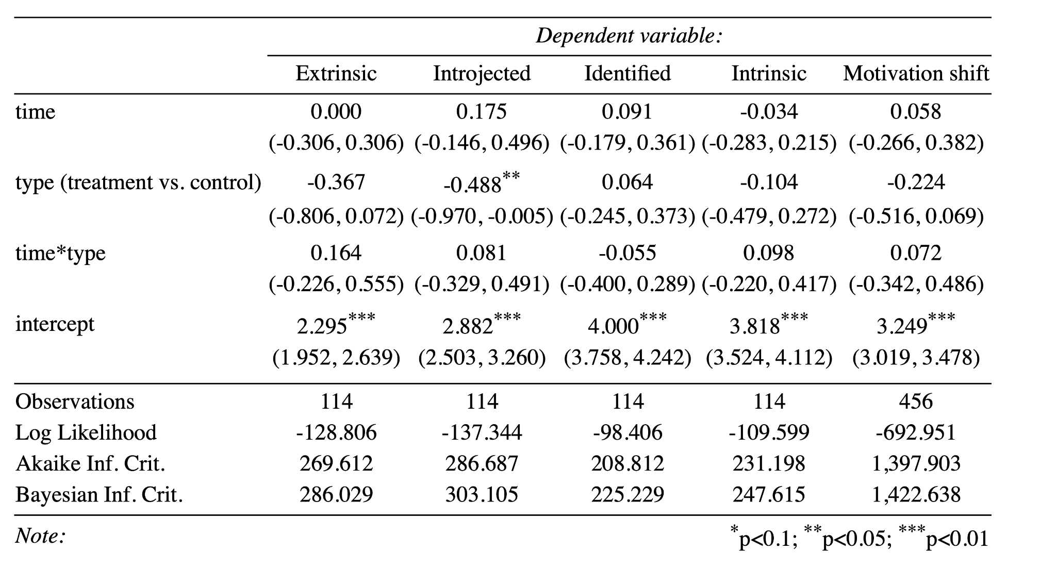

References
Meier, Y., Xu, J., Atan, O., Schaar, M. van der, 2016. Predicting Grades. IEEE Transactions on Signal Processing 64, 959–972. https://doi.org/10.1109/TSP.2015.2496278
Pedregosa, F., Varoquaux, G., Gramfort, A., Michel, V., Thirion, B., Grisel, O., Blondel, M., Prettenhofer, P., Weiss, R., Dubourg, V., 2011. Scikit-learn: Machine learning in Python. the Journal of machine Learning research 12, 2825–2830.
Tipping, M.E., 2001. Sparse Bayesian learning and the relevance vector machine. Journal of machine learning research 1, 211–244.
Vansteenkiste, M., Sierens, E., Soenens, B., Luyckx, K., Lens, W., 2009. Motivational profiles from a self-determination perspective: The quality of motivation matters. Journal of educational psychology 101, 671.
Vansteenkiste, M., Zhou, M., Lens, W., Soenens, B., 2005. Experiences of autonomy and control among Chinese learners: Vitalizing or immobilizing? Journal of educational psychology 97, 468.

