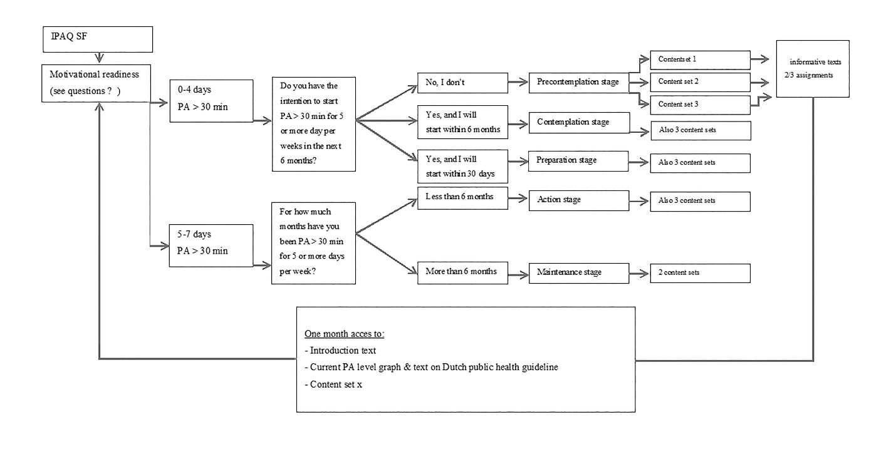
Additional file 1 Overview stage of behavioural change

