CSE - AN ALL-INCLUSIVE BUSINESS MODEL FOR GENERATIONS TO COME
Introduction
This paper explores the concept of Corporate Social Entrepreneurship (CSE) and the need for a transition to a more social, economic, and environmental ‘way of doing business’. According to Austin and Reficco (2009), CSE is not just another form of Corporate Social Responsibility (CSR), but a process for advancing and evolving the development of CSR. To achieve this transition, it is imperative to prepare future entrepreneurs and current businesses to foster the power of entrepreneurship to address societal issues. Hence, the European Corporate Social Entrepreneurship Curriculum (ECSEC) developed by the EMBRACE project partnership is a step in the direction to equip the younger generation, learners in general, business people and educators to navigate through these new complex, chaotic, and uncertain organisational systems. EMBRACE is a three-year initiative funded within the framework of ERASMUS+, Knowledge Alliances programme. The project aims to promote CSE in Higher Education Institutions’ (HEI) educational programmes. The goal is to improve young people’s’ competences, employability and attitudes contributing to the creation of new business opportunities dealing with social change inside companies, as well as promoting collaboration among companies. The project’s overall objective is the establishment of a sustainable environment that facilitates the exchange, flow and co-creation of knowledge between HEIs, enterprises, organisations (public, private and third sector); resulting in the creation of new business opportunities dealing with social change, addressing the Sustainable Development Goals (SDG) within and external to organisations (for further details see http://csembrace.eu/ and EduLab).
Corporate Social Entrepreneurship (CSE) is an emerging concept, concerning new practices. Therefore, inevitably there are still ambiguities and discussions regarding the meaning, relevance, and application of the concept (Couto, Parente, Cruz, Castro and Alegre, 2020). CSE has emerged based on the requirement for businesses to become more socially aware and committed to addressing societal needs and global Sustainable Development Goals (SDG). It is an evolution and the next step from Corporate Social Responsibility (CSR) (Bowen, 1953; Azevedo and Carlos, 2015). CSE embodies characteristics of corporate entrepreneurship - as defined by Schumpeter, Drucker and Stevenson, and the characteristics of social entrepreneurship.
The Path to Corporate Social Entrepreneurship (CSE)
To best grasp the concept of Corporate Social Entrepreneurship (CSE), one needs to understand its origins and the pathway leading to CSE. The concept is considered the evolution and next stage of Corporate Social Responsibility (CSR) (Bowen, 1953; Azevedo and Carlos, 2015), building upon a series of other concepts and embodying relevant characteristics from these (see Figure 1).
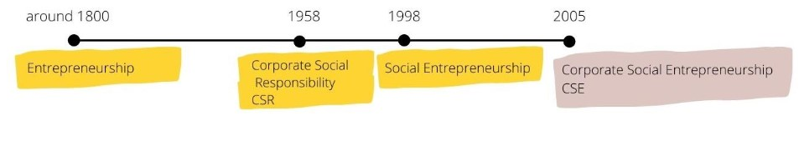
Figure 1. Timeline of broader concepts (EMBRACE, 2020)
CSE emerged from the pressing social and environmental challenges faced, posing risks to society’s well-being and existence as well as addressing the constantly changing environment of business. In addressing these challenges, it is important to understand the fundamental purpose of CSE and the differences between CSE and CSR. Table 1 summarises these differences, where it can be seen that CSE is a more embedded inclusive fundamental process (it is a “way of doing business”) that permeates throughout the whole of organisations be they public, private or third sector organisations.
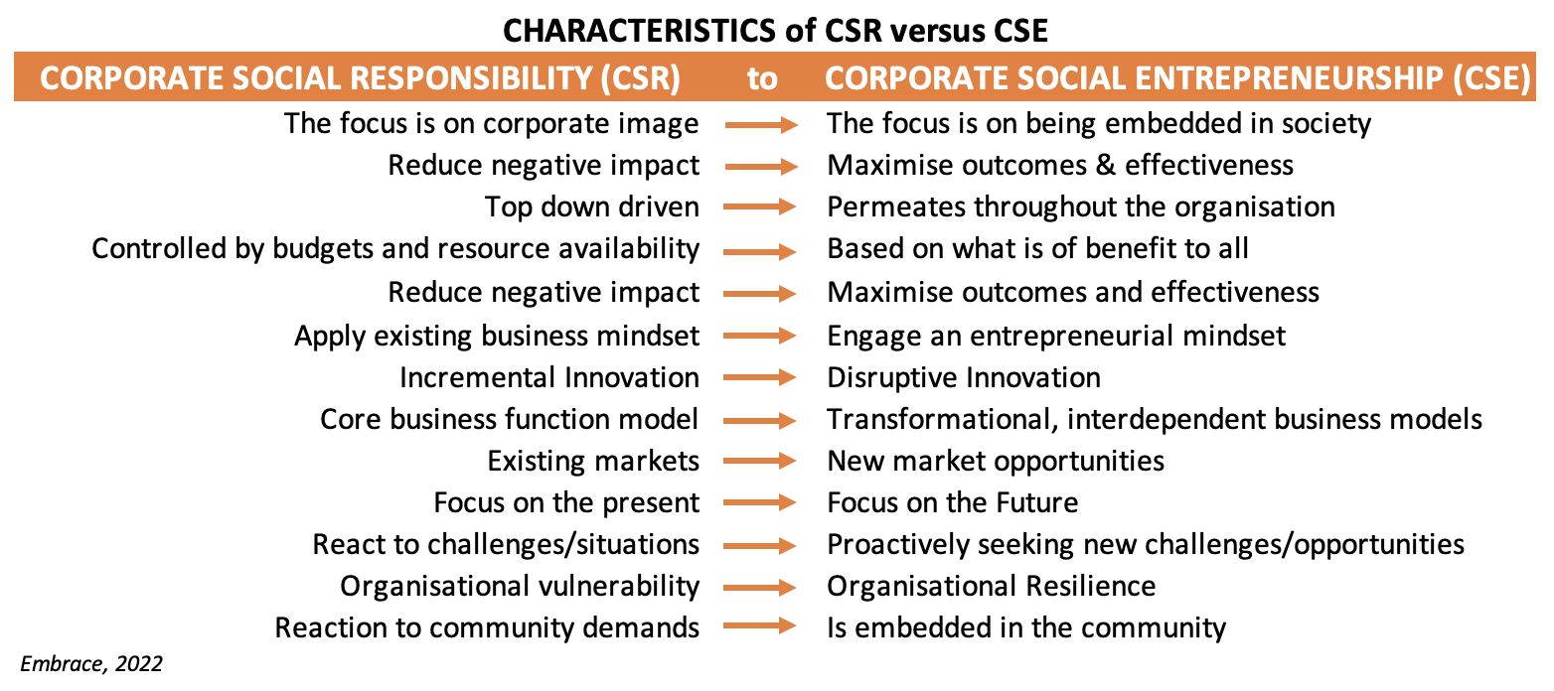
Table 1. Differences between CSR and CSE (Source: EMBRACE, 2022)
Understanding Corporate Social Responsibility (CSR)
CSR can be understood as being “a concept whereby companies integrate social and environmental concerns in their business operations and in their interactions with their stakeholders on a voluntary basis. It opens up a way of “managing change and of reconciling social development with improved competitiveness.” (CEC, 2001, p.7). In other words, CSR delineates the contributions organisations make to society and/or local communities. These contributions can be embedded in the core business, or on the basis of targeted activities to support society. Examples vary from sustainable or ethical (manufacturing) processes and/or products, adopting progressive human resource management practices or supporting not-for-profit initiatives.
There are several terms used to describe CSR in academic literature and on company websites, including, Social Responsibility (SR), and Corporate Citizenship (CC). This results in a range of broad working contexts for CSR. Although McWilliams, Siegel, and Wright (2006) noted that regardless of the terminology used, each one of these refers to how a company goes beyond its remit so that their well-intended actions further some social good, beyond the interests of the firm itself. Essentially, CSR entails the contribution an organisation makes to their local community or to society in general.

Participating companies' CSR activities are manyfold, reflecting the diversity of CSR itself. These activities include social characteristics or features incorporated into a company’s products and manufacturing processes such as developing chemical-free household cleaning products, using environmentally-friendly manufacturing technologies or recycling packaging to be reused for newly created products. CSR also includes the application of progressive human resource management practices in corporate citizenship (for example promoting employee empowerment), achieving higher levels of environmental performance (for example recycling or reducing CO2 emissions) and assisting local or global organisations to achieve their goals, particularly those in the not-for-profit sector. CSR also includes, but is not limited to, supporting social, cultural, sporting, charitable, education, and community development activities in the locality in which the ‘giving’ firm is based.

There is a consensus among a number of articles that establishing a CSR strategy can create a number of business benefits, including staff engagement and retention, improved productivity and innovation, opening up new markets and greater brand awareness and reputation. To go beyond surface-level initiatives for sustainability or corporate philanthropy, leaders in organisations need to form collaborative relationships with employees, stakeholders, clients, partners, academia, government and society to address critical societal issues of the present and the future.

The Theoretical Foundations of CSR
To understand CSR, it is helpful to be aware of the theories which underlie it as these foundational theories also impact the theoretical framework of CSE. CSR is generally categorised into four main theoretical areas: the first two are Shareholder Value and Stakeholder theory stem from economic theory, the third Corporate Social Performance theory evolved from sociology, and the fourth Corporate Citizenship theory originates in political science.

Shareholder Value theory (SVT) holds that the only social responsibility of business is to increase its economic value for shareholders by making a profit. Additional social activities are acceptable only if they increase shareholder value, or if they are required by law (Friedman, 1970). Drucker (1954) claimed profitability and social responsibility can coexist, but at its core, this theory focuses on creating wealth by maximising shareholder value through focusing on the company's activities and that governmental tax systems are in place to facilitate the distribution of some of the wealth of business to society.

Stakeholder theory defines stakeholders as individuals or groups with a "stake" in the company, whether they are beneficiaries or can be adversely affected by the company. Evan and Freeman (1988) formulated stakeholder theory based on two ethical principles; the 'Principle of Corporation Rights' (P1) and the 'Principle of Corporation Effects' (P2). The former establishes that corporations should serve their customers, suppliers, owners, employees, and local communities and each of these groups should have the opportunity to participate in decisions affecting their welfare, and their rights must be protected. The latter implies that the corporation's management bears a fiduciary responsibility to stakeholders and must act in their interest as well as that of the corporation.

Corporate Social Performance theory evolved from several approaches building on theories by (Sethi, 1975; Carroll, 1979; and Preston and Post, 1981). Carroll first introduced the concept of corporate social performance outlining a set of four obligations an organisation has to society; economic, legal, ethical and philanthropic and created the ‘Pyramid of Corporate Social Responsibility’. This was revised by (Carroll and Schwartz 2003) to three core domains; economic, legal and ethical in a Venn model framework. By integrating these three domains the model describes the organisation's efforts to meet changing societal conditions and provides a starting point to motivate and guide the activities of the business.

Corporate Citizenship theory has its roots in political science where ‘citizenship’ is at the core of the concept and reflects the participation of business in society and, as noted by (Matten, Crane and Chapple 2003), business has its rightful place in society, next to other ‘citizens’ with whom the corporation forms a community. Corporate citizenship is concerned with both the ethical and social responsibilities of business as well as its role in protecting and respecting human rights. According to (Gardberg and Fombrun, 2006), corporate citizenship activities have a global reach, enhancing an organization's reputation, and can achieve long-term financial results since they are in fact strategic investments.

These theories can all be used to explain what companies are doing in the area of CSR. However, in practice, companies follow different models. According to (Melé, 2008), a strong normative theory is necessary with a solid philosophical foundation for it to be truly effective. It must reflect a perspective on humanity, business, and society. Therefore, it should be noted that each of the theories presented has a different philosophical foundation, as well as both positive and negative attributes. The core foundation of CSE involves aligning humanity, business and society to address and find solutions for what are often complex societal challenges.

The reason for CSE
The concept and practice of CSE is very valuable as a next step in the work of CSR and addressing contemporary challenges. CSE is built upon the idea that a business can enhance their CSR by changing the way a company operates with a few central elements: creating an innovative and enabling environment, highlighting corporate values and purpose, and building alliances to produce double value (Austin and Reficco, 2009; Agrawal and Sahasranamam, 2016). However, CSE is an embryonic concept which offers the potential for making powerful forms of CSR; it is also a combination of entrepreneurship and social value creation (Agrawal and Sahasranamam, 2016) which is in line with shared value, as a new approach for improving the relationship between business and society (Porter and Kramer, 2011; Michelini and Fiorentino, 2012). It is the new, refreshed and updated version of CSR, “the face of new avatar of caring capitalism in the present scenario” (Tiwari, 2015, p. 12).

The environment of businesses is faced with changes driven by geo-politics, climate and financial crises, a global pandemic, threats to democracy and increased disinformation. These changes demand new leadership and business models which promote resilience in organisations. Moreover, the Sustainable Development Goals (SDGs) follow the Millennium Development Goals (MDGs), expanding the challenges that must be addressed to cover a wide range of interrelated topics, in the economic, social and environmental dimensions of sustainable development. For the implementation of the 2030 Agenda on the SDGs, it is urgent that organisations integrate these goals in their decision-making and that they contribute with their power of innovation for a more sustainable and inclusive future. There is a clear need for new types of interactions and commitments suitable to the ever-changing context of business and society (Uhl-Bien and Arena, 2017). CSE supports these activities by building the resilience organisations need to ‘future-proof’ themselves and become adaptive and address these SDGs.

As highlighted in the “Handbook for Corporate Social Entrepreneurs” (EMBRACE, 2021), CSE is a rather new concept which can be confused with CSR. Austin and Reficco (2009) argued that CSE is, in fact, a process that allows and enables businesses to produce more advanced forms of CSR. CSR, in fact, can be considered as a subset of CSE. CSE entails the pursuit of initiatives with social and environmental ends while taking into account the economic responsibilities of organisations. In contrast to CSR, CSE specifically requires entrepreneurial action and innovation as driving forces, going beyond the ongoing societal engagement of organisations to entail the identification of opportunities to create future goods or services that address social and environmental challenges (EMBRACE, 2021). Venn, R. and Berg, N. (2013) describes social intrapreneurship (a concept that can be used interchangeably with CSE) as an entrepreneurial activity that merges social impact creation and commercial growth. They put it forward that social intrapreneurship in for-profit organizations creates pioneering solutions to complex social problems, spanning internal and external boundaries between divisions, organizations and sectors to achieve mutual value. According to (Haski-Leventhal, Glavas, and Roza, 2020), CSE is a hybrid concept, mainly based on two previously developed concepts: social entrepreneurship and intrapreneurship. Due to the novelty of the concept, a common definition of CSE has not yet been agreed upon. However, the EMBRACE project team, based on research conducted in 34 countries involving the analysis of 75 organisations, 41 interviews with company managers (25) and experts (16) and 220 responses to an on-line survey, define CSE as:
“A way of doing business' so that all staff in any given organisation (public, private or third sector) are fully aware of their role, responsibility and contribution to the sustainable socioeconomic enhancement of their organisations and the communities in which they live and work. The CSE process includes: creating an enabling entrepreneurial environment, fostering corporate social intrapreneurship, amplifying corporate purpose and values as well as building strategic alliances in order to solve economic and social problems and to promote the success of emerging innovative business strategies” (EMBRACE, 2021, p.10).

As today’s business landscape is increasingly influenced by the evolving pressures and preferences of consumers, regulators, and other stakeholder groups, not to mention the impact of ongoing COVID-19 pandemic, CSE plays an integral role in helping firms remain competitive and find new growth opportunities. In this sense, we can argue CSE is the new CSR, a step forward for the post pandemic re-launch of local economies. The EMBRACE project uses its CSE curriculum to equip younger generations with the skills and competences to empower them to be major contributors is addressing societal need within the organisations within which they will work.
The Journey from CSR to CSE
The journey from CSR to CSE is depicted in Figure 2. The progression is achieved by shaping corporate social entrepreneurs through both education and practice. To progress from organisations with strategies reflecting CSR responsibilities (philanthropy, economic, legal, and ethical) to organisations with missions and strategies reflecting the CSE responsibilities (entrepreneurial, innovative, ecological, social, ethical, legal, and economic) in transversal and long-term activities, as depicted in Figure 2, individuals need a unique set of skills and competences. In specific terms, skills and competences that fuel an organisation with entrepreneurial endeavour and innovative value providing inspired self-sufficiency and sustainability in its community; which leads to a sustainable all-inclusive business model for generations to come.

Considering that CSE is still a relatively new concept at its preliminary stages of development, the EMBRACE project team found that only 2 out of 602 HEIs reviewed offer CSE specific courses (EMBRACE, 2020); and that the concept of working as a change agent within companies to create value is increasingly more present in MBA curricula and for executives (Malinsky and McGaw, 2019); and also that the Corporate Social Entrepreneur has been defined as an individuals who is eager to bring social change in their respective communities, regardless of their position in the company, and carries a specific set of skills (EMBRACE, 2021). This enabled the EBRACE project team to the develop of a multidisciplinary European Corporate Social Entrepreneurship Curriculum (ECSEC) (see www.csembrace.eu and www.cselab.eu ).

Specifically, the ECSEC has been developed by the EMBRACE project partnership, with the aim to increasingly include CSE as part of business education as early as undergraduate level and all levels within organisations from operatives to senior executives; and to equip the younger generation with the competences and skills that will empower them to be major contributors to business models for generations to come. The ultimate goal is to assist in the progress and implementation of embedding CSE as a norm in organisations (public, private, and third sector) context to address SDGs while at the same time supporting the generations of excess income over expenditure in the organisation.
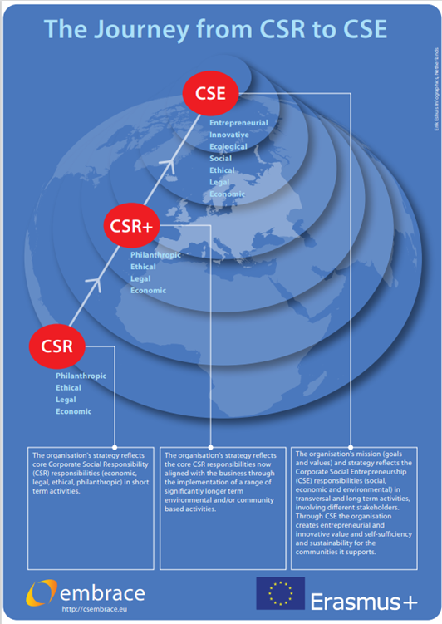
Figure 2. The journey from CSR to CSE (source: EMBRACE, 2022)

The corporate social entrepreneur
As aforementioned, the corporate social entrepreneurs are individuals who are motivated to bring social change to their community, and working environment, and are valuable because they contribute with a unique set of skills complementary to the traditional business management skills (EMBRACE, 2021). The nature of CSE has been established as progression from CSR and the combination of corporate entrepreneurship and social entrepreneurship. Hence, the corporate social entrepreneur can be “characterized by a mind-set to strive for societal value creation in a persistent, learning and outreaching manner and apply the skills of entrepreneurship and communication” (Grayson, McLaren and Spitzeck. 2014). Put simply, the social corporate entrepreneur carries a combination of traits of a social entrepreneur and corporate entrepreneur, combining not only the ability of pursuing and exploring opportunities in an innovative way but also the ability to incorporate social and environmental concerns, values and impact at the core of their business (EMBRACE, 2022).
Based on the research conducted, the competences of a corporate social entrepreneur were defined on the basis of the above, leading to the development of a curriculum that equips individuals with the necessary skill set and competences to pursue CSE.
Readying corporate social entrepreneurs
Four proficiency levels were identified for CSE: Novice, Intermediate, Professional and Expert; each reflecting the role of CSE the professionals will take in their organisations (see www.csembrace.eu and www.cselab.eu ).. The Novice corporate social entrepreneur has basic awareness of the concepts and potential of implementing CSE in their organisation. The Intermediate corporate social entrepreneur is an individual who may not be a business professional but has an understanding of CSE and is able to identify and apply CSE strategies in practice. The Professional corporate entrepreneur is one who is immersed in business knowledge and/or practice, with specialised knowledge in CSE enabling them to identify, design and implement purposeful business propositions. Finally, the Expert corporate social entrepreneur, and the highest CSE profile, is able to design, facilitate and realise CSE strategies and mobilise others to address those strategies (EMBRACE, 2021). The EMBRACE project partnership has developed an online education platform (www.cselab.eu ) offering modules and courses designed to train individuals for each CSE proficiency level, as well as a model for curriculum development, suitable at EQF levels 5 through 7.
CSE, an All-inclusive Business Model for Future Generations
Organisations which transition to CSE can build, align or merge their philanthropic business model with their core business model. True benefit comes when the organisation’s commercial and philanthropic purposes and values are strongly aligned. As noted CSE thrives when the activities the organisation undertakes are aligned with the purpose and values of the organisation. This allows everyone in the organisation to participate and for CSE to permeate throughout the organisation. CSE has entrepreneurship at its core and requires the organisation and its employees to engage a creative mindset to bring entrepreneurial and innovative solutions to bear in addressing societal challenges. This requires the organisation to look at the challenge using different lenses which may bring other requirements to the fore or require new ways of working. An example from the EMBRACE project saw the need for a data analytics platform to be designed and built for an NGO. A key requirement was that the platform would have ongoing low cost of ownership, would be easy to administer and maintain as the NGO lacked technical skills and, the platform needed to support the NGO to become a self-sustaining entity. These are not unheard of goals for a commercial technical engagements but the likelihood is that cost of ownership would be the only one of these items in the top 5 business requirements. This example provided genuine entrepreneurial and innovative challenges for the employees working on the project to overcome. In achieving the goal the skills competencies they developed can now be implemented on core business challenges. As organisations engage with social entities in CSE projects they foster new relationships with other corporate entities facilitating collaboration which can lead to new business/commercial opportunities; which in turn, can lead to new products, processes, markets and revenue streams. Therefore, engaging in CSE to develop solutions for societal benefit can result in new commercial engagements, but also solutions created for a societal benefit can be repurposed for the commercial market.

Today’s younger generation in the workforce is driven to find meaning and purpose in the work they do and in the organisations they work for. An article by (Gartner, 2022) highlighted that employees are motivated when they are appreciated and can contribute to the organisation. Employees want acknowledgment, growth opportunities and to feel valued, trusted and empowered. They are looking for a value proposition that puts them at the core of the organisation: asking employers to recognise their value and to provide value to them at a human level. This includes deeper relationships in the workplace, building a strong sense of community, and providing purpose-driven work. These key employee expectations are challenging leaders in all organisations public, private, academic and third sector to evaluate their future and purpose. At board level, leaders are defining strategies to incorporate the voices of society, clients, shareholders and employees, especially younger generation employees, into how they evolve their workplace and the work of their organisations. Adopting CSE projects to address societal challenges has the capacity to capture the hearts and minds of employees, especially younger generation employees, to create purpose and meaning. A study by (Kim & Kim 2020) draws attention to the importance of CSR to employees, in particular to how perceived management support for CSR has a positive impact on employee engagement, which can only be enhanced through an organisations engagement in CSE. The Sustainable Development Goals (SDG) are becoming more critical and organisations seek to embed solutions based on the goals in their business operations. In the same way aligning CSE with the organisation’s core purpose and values and selecting societal challenges that align well with the organisation’s core business operations will embed CSE into the organisation’s business model and create an all-inclusive business model for the organisation and for current and future generations of the workforce.

Implications of the Study

Corporate Social Entrepreneurship (CSE) is 'a way of doing business' so that all staff in any given organisation (public, private or third sector) are fully aware of their role, responsibility and contribution to the sustainable socioeconomic enhancement of their organisations and the communities in which they live and work. Corporate Social Responsibility (CSR), on the other hand, is often understood as “a concept whereby companies integrate social and environmental concerns in their business operations and in their interaction with their stakeholders on a voluntary basis. (…) It opens a way of managing change and of reconciling social development with improved competitiveness.” (CEC, 2001, p.7). Whereas there is an overlap between CSE and CSR and a similarity of concept, they are on very different trajectories. CSE is not just another form of CSR, it is a process for invigorating and advancing the development of CSR. CSE provides an approach that will accelerate the CSR journey. The fundamental purpose is therefore to accelerate companies’ organisational transformation into a more powerful generation of societal betterment (Austin and Reficco 2009, p.2). CSE has the capacity and capability to empower younger generations to be major contributors to societal and environmental changes within organisational settings; and also to empower younger generations to reshape business models and paradigms for future generations.

The concept of CSE as an evolution of CSR to meet current needs and expectations of society of businesses to take ownership for urgent, complex challenges as good ‘corporate citizens’ plus the ‘business sense’ to create business opportunities in the process implies a need for business development and transformations. This, in turn, implies new competences for current and future leaders and staff are needed and therefore the offer of CSE curricula in education and trainings programmes. The study has also indicated the potential value of CSE to integrate overlapping and parallel areas of theory related to CSR and concepts of intrapreneurship, (corporate) entrepreneurship and social entrepreneurship in business and management fields.
Conclusion
In conclusion, based on our research to date, we argue that Corporate Social Entrepreneurship (CSE) can build resilience in organisations to ‘future proof’ themselves against, or at least be adaptive to manage unforeseen emergencies (such as pandemics and global economic crises), creating opportunities to cultivate, nurture, and catalyze systemic change within and outside their organisations; while at the same time empower younger generations to drive societal and environmental challenges.. Therefore, corporate social entrepreneurs need to embark on a leadership journey, cultivating, developing, and sustaining conditions whereby transformations take place. The European Corporate Social Entrepreneurship Curriculum (ECSEC) (see http://csembrace.eu/) and the CSE EduLab (see http://csembrace.eu/) will bring you on that journey. Although CSE is a relatively new concept our research highlights a number of important reasons why CSE can be an all-inclusive business model that supports an organisation in attaining its commercial business objectives while having a positive impact on society and addressing key societal issues. This has a direct positive impact on employee, as well as younger generation engagement and empowerment to do purpose driven work.

References
Austin, J. and Reficco, E. (2009), Corporate Social Entrepreneurship, [ebook] Boston. https://citeseerx.ist.psu.edu/viewdoc/download?doi=10.1.1.366.867&rep=rep1&type=pdf
Agrawal, A, and Sahasranamam, S. (2016), “Corporate social entrepreneurship in India”, South Asian Journal of Global Business Research, Vol 5 No. 2, pp. 214-233
Azevedo, C. & Carlos, F. (2015), Empreendedorismo Social Corporativo – Conceitos e Práticas, paper presented at the 5th Conferência Ibérica de Empreendedorismo (CIEM) 15 - 18 October 2015, Oeiras, Portugal, available at: Microsoft Word - Empreendedorismo Social Corporativo_V.CIEM_Revisto_20150924.doc (ies-sbs.org) (accessed 4 May 2022)
Bowen, H. (1953), Social Responsibilities of the Businessman, University of Iowa Press, Iowa
Carroll, A. B. (1979), “A Three‐Dimensional Conceptual Model of Corporate Performance”. Academy of Management Review, Vol.4, pp. 497–505
Carroll, A. B., and Schwartz, M. S. (2003), “Corporate Social Responsibility: A Three‐Domain Approach”. Business Ethics Quarterly, Vol. 13 No. 4, pp. 503–30.
Commission of European Communities [CEC]. (2001), Green Paper - Promoting a European Framework for Corporate Social Responsibility, available at: https://ec.europa.eu/transparency/regdoc/rep/ 1/2001/EN/1-2001-366-EN-1-0.Pdf (accessed 4 May 2022)
Couto, A. I., Parente, C., Cruz, S., Castro, F. & Alegre, T. C. (2020). “The state of Corporate Social Entrepreneurship (CSE) in Higher Education Institutions (HEIs): the Portuguese case”, paper presented at the 36th IBIMA - International Business Information Management Association IBIMA Conference, Granada, Spain, available at: The state of Corporate Social Entrepreneurship (CSE) in Higher Education Institutions (HEIs): the Portuguese case | International Business Information Management Association (IBIMA) (accessed 4 May 2022)
Drucker, P. (1954), The Practice of Management, Harper, New York, NY.
EMBRACE (2020), “Review of Corporate Social Entrepreneurship (CSE) Programmes in HEIS – Comparative Report”, available at: http://csembrace.eu/wp-content/uploads/2020/08/Review-of-CSE-in-HEIs.-Final.pdf (accessed 4 May 2022).
EMBRACE (2021), “Handbook for Corporate Social Entrepreneurs”, available at: http://csembrace.eu/wp-content/uploads/2021/06/D8-website-version_09.pdf (accessed 4 May 2022).
EMBRACE (2022), Corporate Social Entrepreneurship Curriculum, available at: http://csembrace.eu/wp-content/uploads/2022/02/EMBRACE_D9_Final_17022022.pdf (accessed 4 May 2022).
Evan, W. M., and Freeman, R. E. (1988), “A Stakeholder Theory of the Modern Corporation: Kantian Capitalism”. in T. Beauchamp and N. Bowie (Ed.), Ethical Theory and Business. Prentice Hall, Englewood Cliffs, NJ, pp. 75–93.
Friedman, M. (1970) ‘The Social Responsibility of Business is to Increase its Profits’. New York Times Magazine
Gardberg, N. A., and Fombrun, C. (2006) “Corporate Citizenship: Creating Intangible Assets across Institutional Environments”. Academy of Management Review, Vol. 31 No. 2, pp. 329–46.
Gartner (2022), “Employees seek personal value and purpose at work: Be prepared to deliver”, available at: https://www.gartner.com/en/articles/employees-seek-personal-value-and-purpose-at-work-be-prepared-to-deliver (accessed 4 May 2022).
Grayson, D., McLaren, M. and Spitzeck, H. (2014). Social Intrapreneurism and All That Jazz. How Business Innovators are Helping to Build a More Sustainable World, Routledge, New York, NY.
Haski-Leventhal, D., Glavas, A., & Roza, L, (2020), “Social intrapreneurship: A new horizon for employee engagement in CSR”, in D. Haski-Leventhal, L. Roza, & S. Brammer (Ed.), Employee engagement in corporate social responsibility. SAGE Publications, London, England, pp. 98–118.
Kim, M. and Kim, J., 2020. Corporate social responsibility, employee engagement, well-being and the task performance of frontline employees. Management Decision, [online] 59(8), pp.2040-2056. Available at: <https://www.emerald.com/insight/content/doi/10.1108/MD-03-2020-0268/full/html>.
Malinsky, E. and McGaw, N. (2019), “Unlocking the potential of Corporate Social Intrapreneurship”, The Aspen Institute, available at: Unlocking-the-Potential-of-Corporate-Social-Intrapreneurship.pdf (aspeninstitute.org) (accessed 4 May 2022).
Matten, D., Crane, A. and Chapple, W. (2003), “Behind the Mask: Revealing the True Face of Corporate Citizenship”. Journal of Business Ethics, Vol. 45 No.1–2, pp. 109–20
McWilliams, A., Siegel, D.S. and Wright, P.M., (2006), “Corporate social responsibility: Strategic implications”, Journal of management studies, Vol. 43 No.1, pp.1-18.
Melé, D. (2008), “Corporate social responsibility theories”, in Crane, A., McWilliams, A.,
Michelini, L. and Fiorentino, D. (2012), “New business models for creating shared value”, Social Responsibility Journal, Vol. 8 No.4, pp. 561-577
Porter, M.E. and Kramer, M.R. (2011), “Creating Shared Value: How to reinvent capitalism—and unleash a wave of innovation and growth”, Harvard Business Review, pp. 1-17.
Preston, L. E., and Post, J. E., (1981), “Private Management and Public Policy”, California Management Review, Vol. 23 No. 3, pp. 56–63.
Sethi, S. P. (1975), “Dimensions of Corporate Social Performance: An Analytical Framework”, California Management Review, Vol.7 No.3, pp. 58–64.
Tiwari, E. (2015), “Corporate Social Entrepreneurship: Face of caring capitalism”, SRF e-Journal of Social Science, Commerce and Management, Vol 1 No. 1, pp. 12-25, available at https://www.academia.edu/14823428/Corporate_Social_Entrepreneurship_Face_of_Caring_Capitalism (accessed 4th April 2022)
Uhl-Bien, M., & Arena, M. (2017), “Complexity leadership: Enabling people and organizations for adaptability”, Organizational Dynamics, Vol. 46 No.1, pp. 9–20.
Venn, R. and Berg, N. (2013), "Building competitive advantage through social intrapreneurship", South Asian Journal of Global Business Research, Vol. 2 No. 1, pp. 104-127. https://doi.org/10.1108/20454451311303310

