Same same, but different..?
The emergence of Public Sector Innovation Labs in theory and practice

Peter MEISTER BROEKEMA
Hanze University of Applied Sciences, Groningen, the Netherlands & University of Groningen, Groningen, the Netherlands
P.Meister-Broekema@pl.hanze.nl

Elisabeth A. M. BULDER
Hanze University of Applied Sciences, Groningen, the Netherlands

Lummina G. HORLINGS
University of Groningen, Groningen, the Netherlands

Abstract
At first glance, Public Sector Innovation (PSI) Labs are gaining prominence within academic literature, the European Union (EU) and beyond. However, because of the relative newness and conceptual ambiguity of this concept, the exact contribution of these labs to theory and practice is still unclear. In addition, most research has been looking at case studies. This publication breaks new ground by elaborating on the concept and also by looking at the perception of these labs in different contexts, by comparing multiple labs in multiple countries. In doing so, we raised the question: ‘What is the perceived added value of Public Sector Innovation labs for further developing theory as well as for society?’ In order to answer this question, by way of an experiment, we combined theoretical research together with focus groups with members of the EU funded project Multi Disciplinary Innovation for Social Change (SHIINE) in combination with questionnaires to selected PSI labs, thus providing us with rich data.
Our experimental methodology uncovered a conceptual bias that is probably existent in similar studies and needs to be acknowledged more. In addition, we found that PSI labs have developed over time into an amalgam of two competing concepts. To conclude, we believe that the specific potential of PSI labs as an internal space for innovation within institutions is underutilised. We believe this could be improved by acknowledging the specific aim of PSI labs in a co-creative setting between relevant stakeholders, such as Higher Education Institutions (HEIs).

Keywords
Public Sector Innovation Labs, Living Labs, Higher Education, Co-creation, Social Innovation, Policy.

Please cite the article as follows: Meister Broekema, P., Bulder, E.A.M., and Horlings, L.G., “Same same, but different..? The emergence of Public Sector Innovation Labs in theory and practice”, Management & Marketing. Challenges for the Knowledge Society, Vol. X, No. X, pp. xx-xx, DOI: XXXX

1. Introduction
Since the early 2000s, there has been a growing interest from the public sector in the co-creation of policies with citizens (Voorberg et al., 2015). This growing interest has been described as a policy paradigm shift from the so-called ‘Traditional Public Administration (TPA)’ via ‘New Public Management (NPM)’, towards ‘New Public Governance (NPG)’ (Hansen & Fuglsang, 2020). Research on these governance approaches is often focusing on the lack of innovation within the public sector, the specific types of innovation within the public sector or the success of public sector innovation as such, without proper ‘falsification of the results’ (Potts & Kastelle, 2010).
The growing interest in co-creation with citizens is also part of a larger shift in society that could be characterised as ‘open social innovation’, combining participatory approaches with social development (Chesbrough & Di Minin, 2014). Social Innovation could be defined as (see Moulaert & MacCallum, 2019 for an overview on this concept):

‘[…] the invention, development and implementation of new ideas with the purpose to (immediately) relieve and (eventually) solve social problems, which are in the long run directed at the social inclusion of individuals, groups or communities.’ (Oeij et al., 2018 p10).

In addition, some new theories and models have been developed that help to understand different forms of social innovation in the 21st century. Notable examples are the different modes (mode 1, 2 and 3) of research by universities and the so-called quadruple helix in which stakeholders from government, universities and enterprises collaborate in the context of society (Carayannis & Campbell, 2009) or recent work on social innovation in higher education (Lepik & Urmanavičienė, 2022). Recently, these types of networks of collaborating and intertwining actors have been dubbed ‘innovation ecosystems’. The word ‘ecosystems’ is used to emphasise the complex interactions and relationships between partners (Gomes et al., 2018). This concept is also being used by, for example, the European University Association (EUA) to emphasise the role of Higher Education Institutions in society (Reichert, n.d.).
The underlying relationship between co-creation and social innovation paved the way for many new concepts that aim to develop long-lasting outcomes that address societal needs together with stakeholders (Voorberg et al., 2015). Starting with the introduction of so-called ‘living labs’ in 2006 (Rădulescu et al., 2022), we witnessed, for example, the birth and rise of ‘policy labs’, ‘innovation hubs’, ‘co-creation labs’ and very recently ‘public sector innovation labs’ (Fuglsang & Hansen, 2022; Hansen & Fuglsang, 2020; McGann et al., 2021; Torvinen & Jansson, 2022). Extensive research has been undertaken into some of these types of labs, mostly focusing on definitions or comparing a couple of case studies. In this paper we focus on the emergence of the Public Sector Innovation Labs in literature and practice, because it is an intriguing concept that suggests a hands-on approach within institutions that could potentially have a large impact on society.
The concept of PSI has been introduced by the Organisation for Economic Co-operation and Development (OECD). Our preliminary definition of these labs is in line with the OECD definition as: ‘spaces where public and private partners work on significant improvements to public administration’ (OECD, 2016). Academic research into this specific type of lab is scarce and very recent, with a first dedicated publication on this topic only dating back till 2017 (Janssen et al., 2017). Researchers in this emerging field are also struggling with the identification of this specific type of lab and have difficulties distinguishing them from policy labs, for example (McGann et al., 2018).
Our paper breaks new ground by focusing on the different perceptions of scholars of PSI labs and the context of these labs, by answering the main explorative research question: ‘What is the perceived added value of Public Sector Innovation Labs for further developing theory as well as for society?’
In order to answer this question, we mapped and analysed academic literature concerning the emergence of PSI labs and used an experimental mixed methods approach. In doing so, we combined data harvested by questionnaires with input from focus groups within the context of the European-funded COST project Multi Disciplinary Innovation for Social Change (SHIINE), that brings researchers from 37 countries together around the concept of PSI (SHIINE - Multi Disciplinary Innovation for Social Change, n.d.). As a result, we could dive deeply into current and potential interpretations of PSI labs and the process of constructing and applying this new concept in practice. The combination of literature, questionnaires and focus groups made it possible to address the following sub questions:

- How are Public Sector Innovation Labs defined in academic literature?
- How are Public Sector Innovation Labs perceived by scholars in different national contexts?
- What are key elements of Public Sector Innovation Labs in different national contexts?

The paper starts with a brief introduction of our experimental mixed methods approach. Subsequently, we will address the three sub questions and discuss our results in the light of other literature. Finally, we will answer our main research question in the conclusion.

2. Methodology
To answer the 1st sub-question and uncover the definitions of PSI labs in academic literature, we carried out a systematic integrative literature review. We used the Preferred Reporting Items for Systematic Reviews and Meta-Analyses (PRISMA) framework (Moher et al., 2009). PRISMA ensures reproducibility and transparency. We carried out our literature review in the Web of Science. We chose this database, because it is one of the largest databases for scientific literature and it also covers the widest variety of topics, ranging from social sciences to natural sciences. The search for ‘Public Sector Innovation Labs’ provided us with fifteen hits.
We downloaded the metadata, such as year of publication, authors’ name and discipline(s) of these fifteen publications into an Excelsheet for general evaluation purposes. Subsequently, we downloaded the full texts in a reference manager (Zotero) and imported the references in a Bibtex file into an online mapping tool (Litmaps)(Litmaps, n.d.) to uncover links between these fifteen publications as well as shared references to key publications that influenced the emerging field of Public Sector Innovation Labs.
After analysing these more general characteristics, we read and analysed the full texts by using a fixed template, that we based on preliminary research into types of co-creation for social innovation. Key elements of this template were the academic definitions of PSI labs used in the publication, the aim of the PSI lab(s), the type of stakeholders involved in the PSI lab(s), the management of the innovations in the PSI lab(s) and we also allowed some space for other specific insights.
To be able to answer the 2nd and 3rd sub research questions on the perception and key elements of PSI labs in different national contexts, we employed two strategies. At first, we used the expertise of a group of social sciences researchers from multiple countries that are working on the emergence of PSI labs within the framework of SHIINE.
As mentioned in the introduction, scholars are having difficulties distinguishing PSI labs from other concepts, such as innovation labs, in the academic literature and use more established concepts to distinguish and analyse PSI labs, which makes it difficult to compare publications and PSI labs. We therefore employed a speculative strategy by first coming up with a preliminary generally accepted definition of PSI labs with researchers from nine countries (Israel, Lithuania, Malta, Moldova, Montenegro, Netherlands, Poland, Romania and Slovenia) during a session of the SHIINE project in January 2020. This definition was based on a wide array of academic and grey literature shared beforehand in combination with the expertise and perceptions of the selected scholars. The given literature focused on PSI labs and their position in the more established field of living labs. We tested this preliminary concept by asking the researchers from these nine countries to briefly map the role and characteristics of PSI labs, based on experience, expertise and a query on the internet.
Secondly, based on the findings of our literature research and the mapping exercise mentioned above, a questionnaire was developed in the spring of 2021 (see annex 1). This questionnaire focused on three key dimensions of Public Sector Innovation Labs, namely characteristics of the organisation, the types of innovation and the management of innovation. The survey has been translated into national languages and by using the preliminary generally accepted definition mentioned above has been sent out digitally via online platform ‘enalyzer’ by a team of twelve researchers to roughly eighty labs in their respective countries (Israel, Lithuania, Moldova, the Netherlands, Poland, Serbia, Slovenia and Sweden), that according to the researchers qualified as PSI labs between December 2021 and April 2022. We also asked the team of researchers to reflect on their criteria to select PSI labs, because this would provide us with valuable insights into the perception and use of PSI labs by scholars in different national settings.
First, we analysed the data from the questionnaires that were sent out to the PSI labs quantitatively with SPSS by looking for descriptive patterns by crosstabs between for examples countries or the aims of the selected PSI labs and then more qualitatively by narratively analysing the arguments from the respondents, in order to understand the trends, similarities and differences between the labs and use this as a benchmark to better characterise the national contexts.
Finally, we discussed the data and our analysis in a final guided focus group with scholars from the SHIINE project, because they are specifically working on the emergence of PSI within SHIINE. We invited six scholars from different countries, because they could provide us with detailed information from different parts of Europe (Italy, Lithuania, Moldova, the Netherlands and Poland). During the session, the scholars were subsequently asked to map Public Sector Innovation labs, and other types of labs in a digital canvas exercise. In this canvas, the scholars had to individually name and position virtual sticky notes on a grid. This exercise was followed by a group discussion. The combination of these interpretations of concepts and the description of the PSI lab landscape gave us insights into the perceptions of PSI labs in general and within different national innovation contexts.
The combination of the literature review, mapping exercises and results from the questionnaire sheds light on the theoretical development thus far and practical implementations of these types of labs.

3. Results
3.1 Literature review
A query on ‘Public Sector Innovation Labs’ in Web of Science revealed that in total only fifteen papers have been published mentioning this specific concept until the beginning of 2022 (Document Search - Web of Science Core Collection, n.d.). The first academic publication that mentions PSI labs can be traced back to 2017 (Janssen et al., 2017). Most publications (n=10) are coming from European countries, four of them from Australia and one from Canada. Twelve out of fifteen publications have been categorised by Web of Science in the research disciplines ‘Public Administration’, ‘Management’, ‘Economics’ and ‘Business’, partly mirroring research on similar emerging concepts as co-creation or open innovation also having their roots in economics (Meister Broekema et al., 2021a).
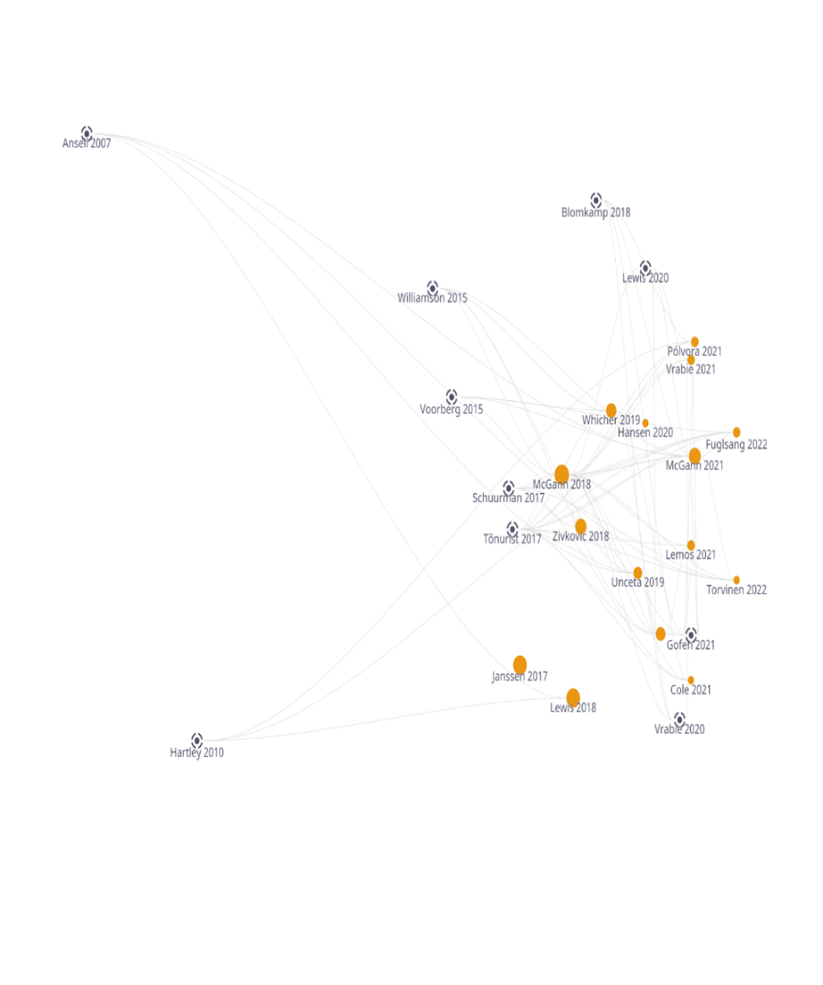
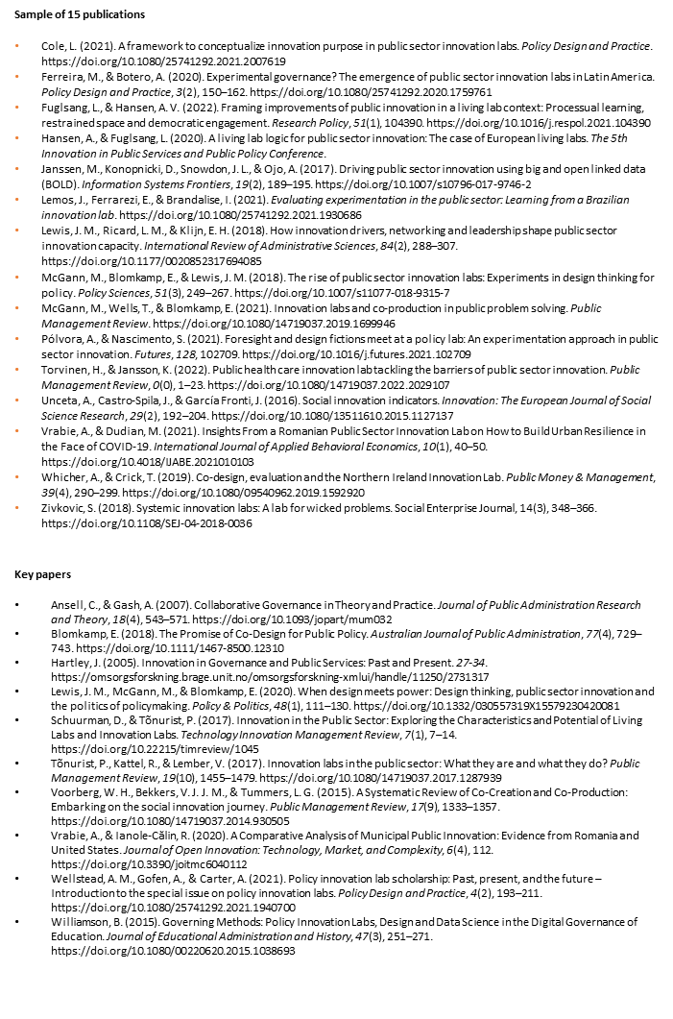
By analysing the references from these fifteen publications with the online tool ‘Litmaps’ (see Figure 1), we noticed that the emerging field of the study of Public Sector Innovation Labs can be described as a specification or combination of literature that is rooted in the broader fields of public sector innovation and living labs (Schuurman & Tõnurist, 2017). In addition, the literature shares some characteristics with research on collaborative government (Ansell & Gash, 2007) and, finally, it is rooted in combinations of research on social innovation and co-creation as well (Voorberg et al., 2015).
Figure 1 Literature references of papers on PSI labs in the Web of Science The orange dots represent our sample of fifteen papers. The larger the dot, the more references to this paper. The black dots represent key papers that have been cited multiple times by the orange coloured sample of fifteen papers. The lines reflect the citations between the papers.
Source: data from webofscience.com visualised with litmaps.com

The integrative analysis of the fifteen publications shows that, although no joint definition was found in the literature, we still found some common ground and can characterise PSI Labs as dedicated places focused on innovation that are sometimes more internally driven (e.g. organisational) and sometimes more externally driven (e.g. systemic).
The difference between an internal or external focus of innovation is also mirrored in the most commonly used descriptions of Public Sector Innovation Labs, such as ‘islands or bastions of experimentation’ (Torvinen & Jansson, 2022; Whicher & Crick, 2019) and ‘next generation of labs that focus on wicked problems’ (Cole, 2021). The first description focuses on a dedicated place for innovation within institutions and the latter is often a space outside institutions that focuses more on societal aims. A special category within the broader interpretation of PSI labs in the analysed literature are policy labs, that sometimes include non-governmental stakeholders and aim to create new policies (Unceta et al., 2019).
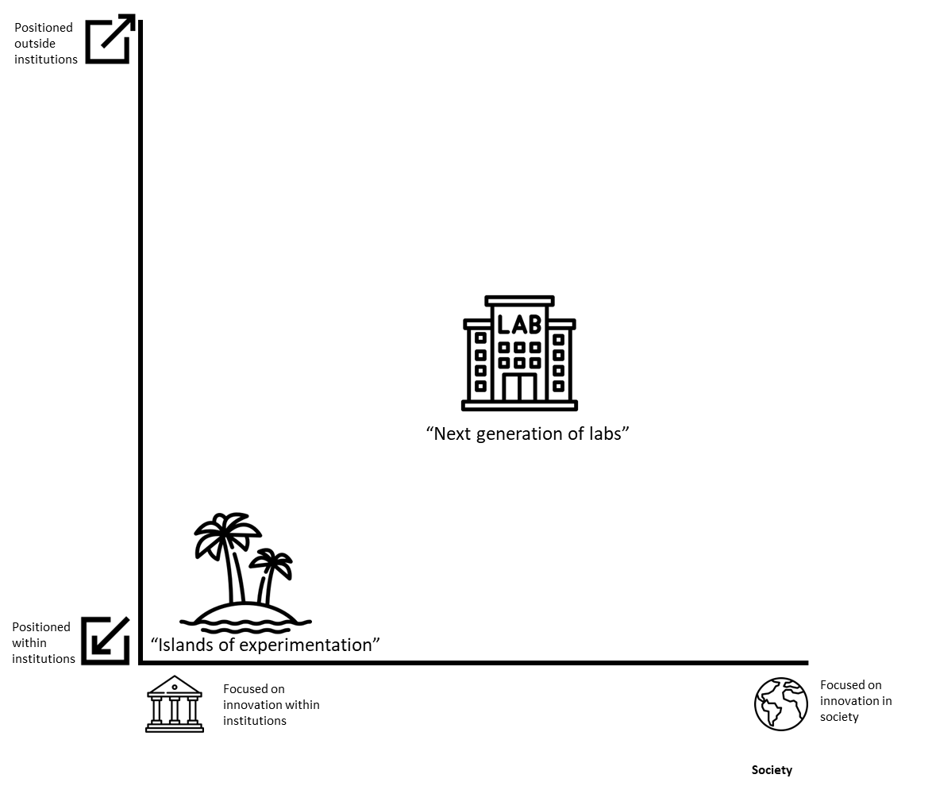
We wanted to be able to better distinguish between different types of labs and decided to use the internal position and internal outlook of ‘islands of experimentation’ and the more external position and external outlook of “next generation of labs” to come up with a grid (Figure 2). The x-axis captures the outlook and the y-axis captures the position of the labs within or outside institutions. We positioned the two types of Public Sector Innovation Labs in the literature (‘islands of experimentation’ and ‘next generation of labs’) on this grid to clearly show differences within the dynamic concept of PSI labs.

Figure 2 Relation between two definitions of PSI labs based on an integrative literature review. This figure shows the two concepts of PSI labs that could be described as ‘islands of experimentation’ and “next generation of labs”, based on societal outlook and position outside of institutions.
Source: Authors’ own depiction. This figure has been designed using icons from flaticon.com.

3.2 Perceptions of PSI labs by scholars
We also noticed the breadth in the interpretation of PSI labs when we asked a group of 11 scholars from the SHIINE consortium coming from multiple countries to come up with a definition of PSI labs based on given literature and their own experiences in January 2020. They constituted the following definition:

‘A PSI lab is a physical or virtual sustainable environment that brings together relevant stakeholders and aims to create value for the community - sometimes through an innovative Public Sector - by rapidly, efficiently and transparently coming up with experimentally proven ideas for bottom-up collected social challenges (ranging from enhancing policy and service design, new innovative products, social inclusion and individual wellbeing) that needs to be implemented and monitored’

This definition blends different aspects of definitions from the literature analysed together, with a preference for the interpretation of the ‘next generation’ types of labs, combining social challenges with value and stakeholders. Interestingly, these scholars agreed that involvement of the public sector is not always necessary for public sector innovation, thereby highlighting that the public sector could also be innovative or innovated via another group of stakeholders or institutions. In addition, the group of scholars also focused on the implementation of the generated ideas and evaluation of these PSI labs, which indicates that according to them a lab should have a longer term focus instead of being a short-term experiment.
The findings from this exercise corroborated with our literature mapping exercise in Figure 1. Scholars in our sample of fifteen publications also use these more established concepts to explore and analyse PSI labs (Cole, 2021; Unceta et al., 2019; Whicher & Crick, 2019). In our group of scholars we also clearly noticed that the researchers use more established concepts, such as living labs (Hansen & Fuglsang, 2020), innovation labs (Cole, 2021) and (public) policy labs (McGann et al., 2018) to understand the concept of PSI labs.
After developing a mutual definition, we asked the researchers from SHIINE to test the applicability of the concept in their countries, by using the definition to find and distinguish PSI labs from other types of labs in their country. This exercise revealed that there are many differences in the perceived definitions of PSI labs by the scholars, and differences between the countries. The scholars from Israel, Poland and Slovenia, for instance, described a tendency towards a focus on technology. In addition, scholars from Moldova pointed more towards policy innovation and e-services. Scholars from the Netherlands, Malta and Lithuania concluded that PSI labs in these countries are more inclined to work towards social innovation as an aim. However, due to the subjective nature of these conclusions and the relatively low number of scholars, it is difficult to draw general conclusions.
Because we noticed the variety in labs, we also asked the scholars to reflect on the selection process for PSI labs. The outcomes of this reflection exercise made it clear that the researchers not only used more established concepts to find and distinguish PSI labs, but they also used more generic search terms, such as ‘social’ and/or ‘innovation’. In addition, it also revealed that researchers started looking for PSI labs in their own existing networks, which implies that they could be tempted to retrospectively label ongoing activities as PSI. Some scholars had a tendency towards the internally focused “islands of experimentation”, while others were much more inclined towards the social aims “next generation of labs”. Scholars, for example, included labs, such as the IT-orientated TEKWILL initiative from Moldova, a Polish NGO called Shipyard that supports hospice care in rural areas, and Italian Public Administration labs.
A separate positioning exercise in connection with the developed two-axis model mentioned above by a selection of six SHIINE scholars coming from a variety of countries in Europe, namely, Italy, Lithuania, Moldova, the Netherlands and Poland (Figure 3) showed that, in their opinion, the concept of PSI was more multifaceted than our literature review suggested (Figure 2). Superficially, we could again distinguish between two interpretations of the concepts centred around the internally focused and positioned ‘islands of experimentation’ and more outward looking ‘next generation of labs’. However, it was also clear that the definition of PSI for some scholars transcended beyond the ‘next generation of labs’ in the sense that it was identified with projects or activities primarily focused on social innovation and sometimes on more externally positioned labs as well.
By asking the six scholars to map and position other types of ‘labs’ in relation to their perceived definition of PSI labs by SHIINE scholars in their country, we aimed to construct an image of the innovation ecosystem in different countries. Discussions during this exercise also revealed that the term ‘lab’ is restricted to scientific laboratories in some countries. In addition, it was hard to map the field, because many innovations are taking place under the radar or are not easily findable on the internet.

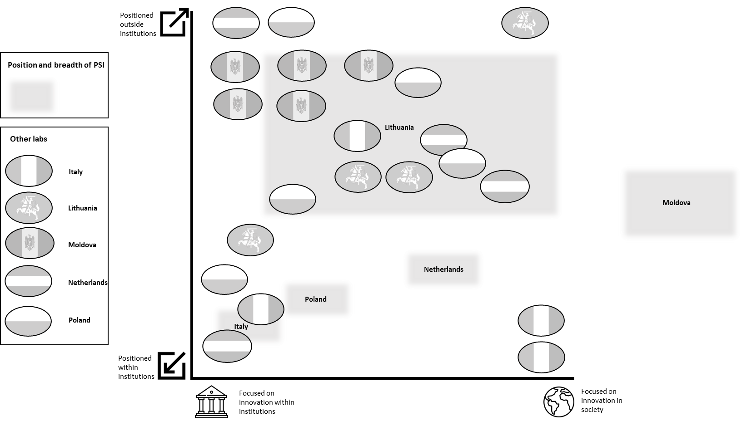
Figure 3 Perceived definition of PSI labs in five countries in relation to other types of ‘labs’. This figure shows the overlap of PSI labs with other types of labs in different countries and shows the ambiguity of the concept in different national contexts.
Source: Authors’ own depiction based on focus group with six participants in May 2022.
This figure has been designed using icons from flaticon.com.

Figure 3 shows the results of both positioning exercises. It becomes clear that there are conceptual differences in different national innovation ecosystems. The figure also makes clear that in most countries there is a distinction between the perceived concept of PSI by SHIINE scholars in their countries and other types of labs. The concept of PSI in Moldova, for example, is perceived to be much more externally focused than existing other types of labs in Moldova. We hypothesise that this is also reflected in a lower position on the Global Innovation Index, mainly due to the strength of national institutions (Global Innovation Index | Tracking Innovation through the COVID-19 Crisis, n.d.). The Dutch, Italian, Lithuanian and Polish PSI definitions are more positioned at the centre with other types of labs. We believe that this indicates that the innovation ecosystem is more refined, mainly because institutions are stronger and subsequently according to research commissioned by the EU, research systems as a whole are more attractive(EIS-RIS 2021 | Research and Innovation, n.d.).

3.3 Characteristics of PSI labs
Based on the group discussions, we realised that the data stemming from the questionnaire that was distributed amongst identified PSI labs were difficult to interpret. This was mainly because the image that emerges was quite heterogenous and the label PSI was often used in retrospect. Our quantitative analysis, for example, showed that only 5 of 35 of the labs labelled as PSI labs were established after the introduction of the concept by the OECD in 2016.
The data from the questionnaire revealed that 17 out of 35 completed questionnaires of the selected PSI labs were being led by the not-for-profit sector (including Higher Education Institutions), 9 of them by the not-for-profit sector and 8 were hybrid. In addition, only 1 lab qualified as ‘private’. A closer analysis revealed that 8 questionnaires could only provide data on an aggregated level. Because we needed a more fine-grained analysis, we decided to discard them for the more refined individual analysis. In addition, we decided not to study the sole ‘private’ PSI lab.

We tried to come up with a typology, by cross comparing the data to see if general patterns would emerge. We noticed for example that more than half (n=15) of the analysed PSI labs (n=26), were often perceived by the people from these labs as independent institutions. We also concluded based on our data that the funding of the labs was dependent on the national infrastructure. For example, Israel was providing structural annual funding for their labs, the Netherlands provided a mixture of project and programme-based funding and in Moldova all labs were based on programme funding. In addition, we also noticed that 22 from the 26 PSI labs were mostly inclined to partner with Higher Education Institutions (HEIs) and civil organisations (n=20) as well. This is in line with former research on co-creation strategies by EU-funded projects, that also showed this preference (Meister Broekema et al., 2021a). Interestingly, the results of our questionnaire also showed that most labelled PSI labs work on a national level, which suggest that they have some ‘critical organisational mass’ and often tackle larger or broader societal challenges.
Because of the conceptual unclarity it is almost impossible to draw conclusions based solely on a quantitative analysis of the data. Therefore, looking at the individual context is essential to understand and analyse PSI labs. Looking at the data from the questionnaire, some labs, for example, answered ‘other’ when asked about the type of organisation, although they were clearly part of governments or universities. This fact is underlined by our former observation that most scholars focus on contextualised case studies.
Based on our data, we only noticed a small variance when we looked at the categories of government-led labs, not-for-profit labs and hybrid labs. As mentioned above, we primarily used the type of organisation that was given by the respondent, however, after careful consideration, we allocated five ‘other’ types of organisations to the three main types mentioned above and manually included the results of these ‘other’ types into the main type. By using these three types and descriptively cross comparing them with the other variables, we were able to subtract more specific characteristics (Table 1).

Table 1 Characteristics of three types of PSI labs.
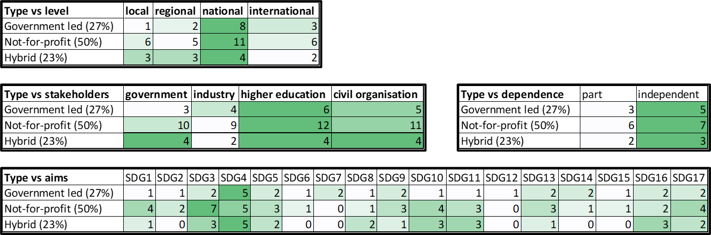

These tables reflect the characteristics of three distinguished types of PSI labs, based on a sample of 26 questionnaires. Except for the dependence table, which reflect the actual n=26, the other tables are more ‘relative’, because PSI labs could subsequently include more levels of cooperation, more types of stakeholders and multiple aims.
Source: Authors’ own research.
As mentioned, the differences between the three types are quite nuanced. However, we noticed some specific characteristics.

- Government-led labs consider themselves mostly as being active on a national level and often have no specific thematic aim, except for a small preference for Sustainable Development Goals such as quality education (SDG4). Furthermore, they are apparently more focused on innovation itself. They collaborate with all types of stakeholders in a relatively even way.
- Labs led by not-for-profit organisations are also primarily focused on the national level, although they also work more on a local and regional level in comparison to government led labs. They are also aiming for more specific challenges, mostly on such as good health (SDG3), quality education (SDG4), poverty (SDG1) and reduced inequalities (SDG10). These types of labs also focus on partnerships for the goals (SDG17), which could imply that they are intrinsically motivated to form partnerships.
- Hybrid labs do not have a clear focus on collaboration on a specific level. In comparison to the other two types of labs they are more focused on specific aims, having a preference for SDG4 (quality education), but are also focused on good health (SDG3), reduced inequalities (SDG10), sustainable cities (SDG11) and peace (SDG16).

These three types of PSI labs share some similarities with three formerly distinguished types of living labs, namely strategic, civic and grassroots in terms of scale of innovation and aims, and also have the same problems in terms of the wide variety of activities (Rădulescu et al., 2022).

3.4 Group reflection on different perceptions
We discussed the perceptions and characteristics of PSI labs with the group of scholars from SHIINE to gain a better understanding of the concept in practice. We used the image of PSI labs in relation to different types of labs as a starting point for this discussion (Figure 3). Despite the conceptual confusion and the strong links between PSI labs and other concepts, the scholars argued that they still see an added value in PSI, mainly because the concept stands out from other similar concepts in their country although there is a clear ambiguity if you try to compare these concepts in different countries.
Therefore, the group concluded that the concept of PSI must be understood in a context that is always in a flux. Although it makes sense to define concepts such as PSI, the results from the questionnaire and mapping exercises showed that concepts are also used to explain ongoing activities that might have been labelled differently before. New types of innovation and social innovation are emerging all the time in different local, national and international contexts. Therefore, it would be helpful to primarily view the implementation of different types of labs as converging points between new policies, new concepts and societal challenges which are also constantly changing. The group members mentioned that concepts are, for example, introduced by governments to tackle specific aims in a specific period, because the political dimension makes it difficult to use the regular budget for new types of challenges. In other words, a new concept could be ‘framed’ as an experiment, which makes it easier to implement and convince public actors (Fuglsang & Hansen, 2022).

4. Discussion
The concept of Public Sector Innovation has been introduced and is currently still being promoted by the OECD, mainly via its Observatory on Public Sector Innovation (Observatory of Public Sector Innovation, n.d.). This is in line with former research on the uptake of policy-orientated concepts. Research shows, for example, that the concept of ‘open innovation 2.0’ with a specific form of co-creation has been quite influential in both academic literature and EU policy after 2014 (Meister Broekema et al., 2021a). The same can be concluded with regard to the emergence and implementation of living labs. These labs first gained attention in 2006 due to EU policies and funding, started in IT and subsequently have been extending rapidly in the domain of public service innovation. In parallel the European Network of Living Labs was formed (Fuglsang & Hansen, 2022).
The development of ‘Public Sector Innovation Labs’ appears to have followed a similar pathway. Policy documents from, for example the OECD, refer to Public Sector Innovation Labs within governmental institutions as early as 2016 (OECD, 2016). Shortly after this, the concept also emerged in academic literature (Janssen et al., 2017). Since that moment it has expanded into other sectors, because it was linked with the concepts of innovation labs and living labs (Schuurman & Tõnurist, 2017). The TEKWILL example from Moldova referred to above mirrors this, because it blends IT and technology with a societal aim.
As shown in our literature analysis, the paper by Schuurman and Tõnurist has been cited many times within the specific field of PSI Labs. We assume that this paper has been influential in supporting a broader use of the concept of these PSI labs within academia. This confirms our finding that the concept of PSI labs is contested within scientific literature and, therefore, it is difficult to distinguish and analyse PSI labs from similar types of labs. In addition, our analysis on the perception of existing PSI labs in different countries shows the difficulty of using the term ‘lab’ in general, which is in line with research on, for example, urban living laboratories (Bulkeley et al., 2019).
Based on this, we argue that the concept of PSI labs is actually multifaceted and is an amalgam of a clear and narrow OECD concept and simultaneously an essentially contested concept as well. Because PSI labs have been introduced and promoted by especially the European Union, it also became part of an emerging policy paradigm that combines open innovation, social innovation and co-creation (Meister Broekema et al., 2021b). Therefore, it is no coincidence that most papers on PSI are written by scholars within Europe. PSI is increasingly used by policymakers, researchers and practitioners as a potential solution to societal challenges, although there is little evidence yet that PSI labs lead to better policies and public service innovations (McGann et al., 2018).
We argue that the conceptual ambiguity not only stems from different interpretations of PSI labs by scholars, but is also heavily influenced by the national, regional or local context of these types of labs and the scholars analysing such labs. As argued by the SHIINE group in the final group discussion, it might be helpful to understand the emergence of PSI labs in a more dynamic framework. We tested this idea by using the so-called Transition Performance Index (Transitions Performance Index (TPI), n.d.) that monitors and ranks countries based on 4 transitions (economic, social, environmental and governance). Based on our definition of PSI labs, we focused on the social and governance transitions. Most countries from our sample showed a clear connection between these transitions in terms of progress. Interestingly, we noticed in the index that Moldova was the only country from our sample whose social transition was stronger than its governance transition. This imbalance might be an explanation for Moldova’s perception of PSI labs as more externally focused on society and different from other labs in the country, where other countries show more nuance (Figure 3).
During our experiment in practice it became very clear that for a lack of a universal definition, most labs are not even identifying themselves as PSI labs. If scholars try to distinguish them from other labs, they use biased understandings of concepts. This could lead to a sample of specific types of PSI labs, in our case to a sample that is often focused on education as an aim, a collaborator or coordinator of a PSI lab. This definition problem is also reflected in the given definition of PSI labs from the scholars that reflects the wish for longer-term experiments, which appears to be the opposite of what policymakers often envision, namely the wish to experiment for a short amount of time (Savini & Bertolini, 2019).
Some authors are trying to understand the position of PSI labs in the context of policy systems (McGann et al., 2018). We believe that the concept of social innovation ecosystems could also be helpful in understanding the added value of PSI labs in different contexts. Social Innovation Ecosystems are namely defined by framework conditions, which make it impossible to replicate social innovations in different contexts (Kaletka et al., 2016). In this model, the authors distinguish four contextual layers of social innovation ecosystems. They distinguish a) roles of stakeholders and beneficiaries, b) functions such as management procedures and governance models, c) structures, such as path dependencies between existing institutions and, for example, economic and political imperatives and d) norms, such as ethical standards, legal conditions, codes and other accepted social standards (Kaletka et al., 2016).

We distinguished between three types of PSI labs. The first, government-led labs overlaps mainly with the narrower OECD definition of PSI labs, appears to be more coherent in terms of for example aims in different contexts. This could be the case, because the roles of the stakeholders and, for example, governance models are better defined and are well aligned with governmental institutions and political imperatives. In addition, the observatory on Public Sector Innovation is also supporting the development of these specific types of labs. However, our research showed that the second and third type of PSI lab, the not-for-profit and hybrid types of labs, have more different types of stakeholders than the first type and have more diverse aims which makes it more difficult to replicate labs and compare them.
Although we started our research to gain a better understanding of the concept of Public Sector Innovation Labs, we found that the use of the term ‘lab’ is quite problematic. As was observed by Bulkeley, amongst others, the term ‘lab’ is not only associated with scientific laboratories but also provides some legitimacy for experiments and in the context of, for example, urban experiments it is also political in nature (Bulkeley et al., 2019; Savini & Bertolini, 2019). If we contrast this with our findings from the focus group sessions, we believe that there is a discrepancy between policymakers and researchers not only in respect of the definition of labs, but also in respect of their aim and duration in general. The former focus more on the use of labs for specific challenges in short-term experiments, mainly due to political pressure, and the latter have a preference for longer, more systemic types of innovation.
Interestingly, the development and changing interpretations of the PSI lab concept share similarities with the development of the concept of living labs. As argued by Rădulescu et al., living labs used to be used in specific contexts, but have now become a magical concept that is almost seen as the only response to all the wicked problems of our time and is therefore promoted and funded on a large scale (Rădulescu et al., 2022).

5. Conclusion
In this paper we explored the added value of the concept of Public Sector Innovation Labs, for further developing theory as well as for society. We did not focus per se on the ‘why’ question of the labs, but mainly on the ‘what constitutes a PSI lab’ question. Although we aimed to contribute to the academic literature by qualitative analysing a larger number of labs, our experimental approach of defining an emerging concept, selecting PSI labs based on this definition and analysing them via a questionnaire, revealed that it is quite difficult to research an emerging concept such as PSI lab.
However, by transparently describing this process, we showed and believe that this ‘perception bias’ might be present in other similar comparative studies as well. Therefore, we believe our novel methodology may provide guidance for similar exercises into the mapping of emerging concepts in the future, because it acknowledges the stubbornness of reality. Future research could incorporate a more flexible framework by using, for example, longer-term transitions in order to understand and compare an ever-changing innovation landscape.
Therefore, in order to understand the added value of an emerging concept, we realised that we needed to integrate our questionnaire approach much more than originally foreseen, with a literature review and focus groups. Initially, we were planning on solely using the literature review to define the academic concept of PSI labs as a starting point for further research and solely use the focus groups and questionnaires to understand the national context and characteristics. However, we realised that these two methods alone cannot provide a complete picture of emerging concepts. Literature reviews merely produce snapshots during the formative periods of contested concepts. Results from focus groups and data from questionnaires are difficult to scale up, due to their size and specific focus. Nevertheless, combining these methods allowed us to see that the concept of PSI is contested, and also to understand how PSIs are perceived in practice in countries with different institutional contexts.
Based on our research we conclude that the theoretical concept of PSI labs could be characterised as an amalgam of two definitions (Figure 4). The narrow definition that is also visible in the data from the questionnaire is based on the OECD definition and is quite clear, is supported by a dedicated observatory and because of this functions as a dedicated place within governments to innovate, preferably with external partners. Therefore, the added value of this narrow concept lies primarily in changing the culture of the Public Sector. This aim is in line with the shift towards New Public Governance and the growing interest in co-creation with citizens. Not only to include the perspective of ‘needs’ as such, but also to stimulate processes of democratisation. This definition transcends definitions such as policy labs, but is also not entirely ‘out in the open’, such as living labs.
The added value of the definition beyond the core OECD definition is more opaque. On the one hand, our analysis shows that in (social) innovation ecosystems PSI labs could fulfil a specific role; a role that includes a wider aim than innovation in the public sector as such. However, on the other hand, a link with the public sector remains essential, to prevent the concept from becoming too fuzzy. This ambivalence in the broader concept makes it very difficult to analyse the concept in different (national) contexts and understand the added value in practice.
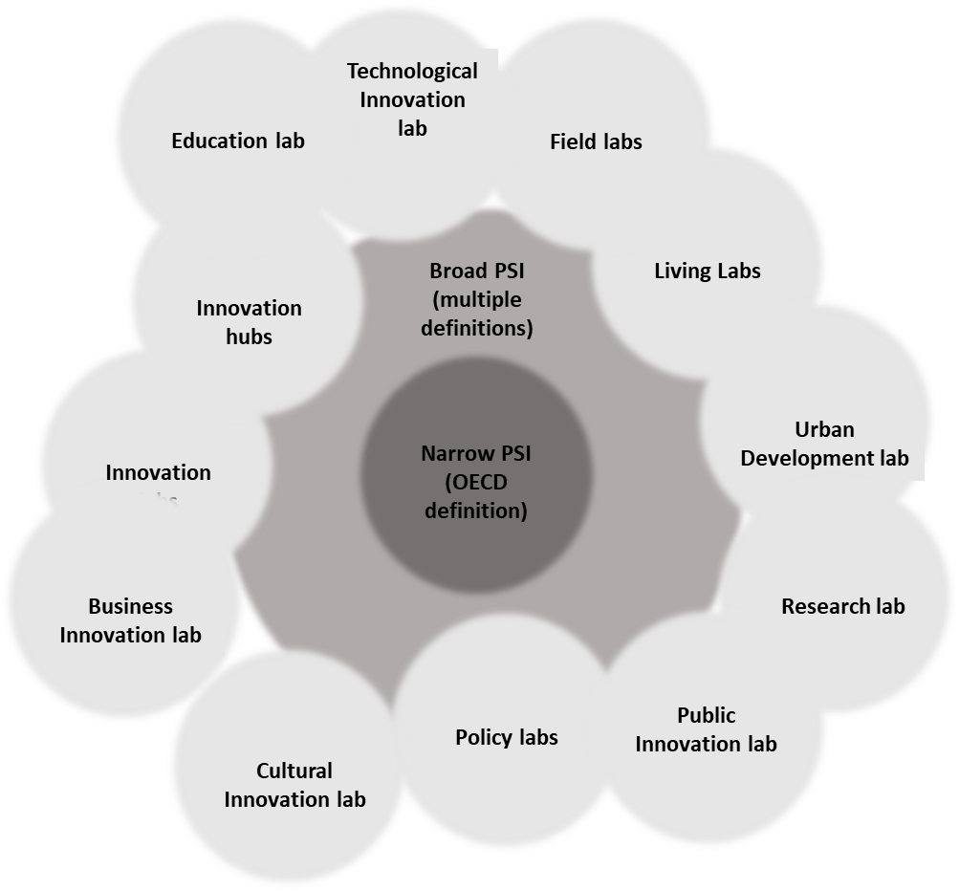

Figure 4 Core- and broader definitions of PSI Labs in relation with other types of labs. This figure shows that the core concept (darkest grey) is quite fixed, but the broader definition (lighter shade of grey) is being influenced by other concepts.
Source: Authors’ own depiction. This figure has been designed using icons from flaticon.com.

We explored the emerging concept of PSI labs in several countries, although we actively selected a variety of countries, we must be aware that our research took place in a small number of countries and that even in this small number of countries there is a wide variety in the definitions used. In addition, the perception bias of scholars we noticed while reflecting on the definition and selection of PSI labs also limits our research. For example we noticed that roughly a third of the PSI labs analysed are affiliated with Higher Education Institutions (HEIs) and more than half of the labs are working on SDG4 (quality education).It is possible that the selection of these PSI labs is biased, because we invited scholars to select them. However, we do suggest that HEIs could play an important role in the social innovation ecosystem, because they are situated between the public sector and society and could consequently act as a bridge by continuously promoting a culture of internal innovation and use this to promote more systematic changes in society as a whole (Berg et al., 2022; Carayannis & Campbell, 2009; Lepik & Urmanavičienė, 2022; Morawska-Jancelewicz, 2021).
Therefore, we believe that the potential added value of the concept perhaps does not lie in its newness or uniqueness, but in its power rather to transform static institutions, such as governments or universities, into more outward facing institutions, by including external stakeholders and/or work in a novel way. The narrow or core definition in combination with the support structure by the OECD ensures a certain ongoing development and implementation of the concept and the broader definition ensures relevance, because the definition is and can be adapted to new environments.
To conclude, the same concept in the same study could mean something different in a different context and we should embrace this difference instead of trying to mould it into a coherent concept for the sake of it.

Acknowledgements
This paper is based upon collaborative work from COST Action SHIINE “Multi-disciplinary Innovation for Social Change”, supported by COST (European Cooperation in Science and Technology).
References
Ansell, C., & Gash, A. (2007). Collaborative Governance in Theory and Practice. Journal of Public Administration Research and Theory, 18(4), 543–571. https://doi.org/10.1093/jopart/mum032
Berg, L. N., Thomas, E., Iakovleva, T., Pinheiro, R., & Benneworth, P. (2022). Universities and Regions: New Insights and Emerging Developments. In Universities and Regional Engagement. Routledge.
Bulkeley, H., Marvin, S., Palgan, Y. V., McCormick, K., Breitfuss-Loidl, M., Mai, L., von Wirth, T., & Frantzeskaki, N. (2019). Urban living laboratories: Conducting the experimental city? European Urban and Regional Studies, 26(4), 317–335. https://doi.org/10.1177/0969776418787222
Carayannis, E. G., & Campbell, D. F. (2009). ‘Mode 3’and’Quadruple Helix’: Toward a 21st century fractal innovation ecosystem. International Journal of Technology Management, 46(3–4), 201–234.
Chesbrough, H., & Di Minin, A. (2014). Open Social Innovation. In New Frontiers in Open Innovation.
Cole, L. (2021). A framework to conceptualize innovation purpose in public sector innovation labs. Policy Design and Practice. https://doi.org/10.1080/25741292.2021.2007619
Document search—Web of Science Core Collection. (n.d.). Retrieved 30 June 2022, from https://www-webofscience-com.proxy-ub.rug.nl/wos/woscc/basic-search
EIS-RIS 2021 | Research and Innovation. (n.d.). Retrieved 27 June 2022, from https://ec.europa.eu/research-and-innovation/en/statistics/performance-indicators/european-innovation-scoreboard/eis#
Fuglsang, L., & Hansen, A. V. (2022). Framing improvements of public innovation in a living lab context: Processual learning, restrained space and democratic engagement. Research Policy, 51(1), 104390. https://doi.org/10.1016/j.respol.2021.104390
Global Innovation Index | Tracking Innovation through the COVID-19 Crisis. (n.d.). Global Innovation Index. Retrieved 27 June 2022, from https://www.globalinnovationindex.org/Home
Gomes, L. A. de V., Facin, A. L. F., Salerno, M. S., & Ikenami, R. K. (2018). Unpacking the innovation ecosystem construct: Evolution, gaps and trends. Technological Forecasting and Social Change, 136, 30–48. https://doi.org/10.1016/j.techfore.2016.11.009
Hansen, A., & Fuglsang, L. (2020). A living lab logic for public sector innovation: The case of European living labs. The 5th Innovation in Public Services and Public Policy Conference.
Janssen, M., Konopnicki, D., Snowdon, J. L., & Ojo, A. (2017). Driving public sector innovation using big and open linked data (BOLD). Information Systems Frontiers, 19(2), 189–195. https://doi.org/10.1007/s10796-017-9746-2
Kaletka, C., Markmann, M., & Pelka, B. (2016). Peeling the Onion. An Exploration of the Layers of Social Innovation Ecosystems. Modelling a context sensitive perspective on driving and hindering factors for social innovation. European Public & Social Innovation Review, 1(2), Article 2. https://pub.sinnergiak.org/esir/article/view/42
Lepik, K.-L., & Urmanavičienė, A. (2022). The Role of Higher Education Institutions in Development of Social Entrepreneurship: The Case of Tallinn University Social Entrepreneurship Study Program, Estonia. In C. Păunescu, K.-L. Lepik, & N. Spencer (Eds.), Social Innovation in Higher Education: Landscape, Practices, and Opportunities (pp. 129–151). Springer International Publishing. https://doi.org/10.1007/978-3-030-84044-0_7
Litmaps. (n.d.). Litmaps. Retrieved 10 May 2022, from https://app.litmaps.com
McGann, M., Blomkamp, E., & Lewis, J. M. (2018). The rise of public sector innovation labs: Experiments in design thinking for policy. Policy Sciences. https://doi.org/10.1007/S11077-018-9315-7
McGann, M., Wells, T., & Blomkamp, E. (2021). Innovation labs and co-production in public problem solving. Public Management Review, 23(2), 297–316. https://doi.org/10.1080/14719037.2019.1699946
Meister Broekema, P., Horlings, L. G., & Bulder, E. (2021a). Tackling societal challenges together Co‐creation strategies and social innovation in EU policy and funded projects. European Policy Analysis. https://doi.org/10.1002/epa2.1133
Meister Broekema, P., Horlings, L. G., & Bulder, E. A. M. (2021b). Understanding the value of co-creation for social innovation interpretations of social innovation and co-creation in European policy-related documents between 1995 and 2018. Innovation: The European Journal of Social Science Research, 1–18. https://doi.org/10.1080/13511610.2021.1909464
Moher, D., Liberati, A., Tetzlaff, J., & Altman, D. G. (2009). Preferred Reporting Items for Systematic Reviews and Meta-Analyses: The PRISMA Statement. Annals of Internal Medicine, 151(4), 264–269. https://doi.org/10.7326/0003-4819-151-4-200908180-00135
Morawska-Jancelewicz, J. (2021). The Role of Universities in Social Innovation Within Quadruple/Quintuple Helix Model: Practical Implications from Polish Experience. Journal of the Knowledge Economy. https://doi.org/10.1007/s13132-021-00804-y
Moulaert, F., & MacCallum, D. (2019). Advanced Introduction to Social Innovation. Edward Elgar Publishing.
Observatory of Public Sector Innovation. (n.d.). Observatory of Public Sector Innovation. Retrieved 13 May 2022, from https://oecd-opsi.org/
OECD. (2016). Public sector innovation. OECD. https://doi.org/10.1787/sti_in_outlook-2016-12-en
Oeij, P. R. A., Torre, W. van der, Vaas, S., & Dhondt, S. (2018). Understanding Social Innovation as an innovation process. TNO. /report-completed-understanding-social-innovation-as-an-innovation-process/
Potts, J., & Kastelle, T. (2010). Public Sector Innovation Research: What’s Next? Innovation: Management, Policy and Practice, 12. https://doi.org/10.5172/impp.12.2.122
Rădulescu, M. A., Leendertse, W., & Arts, J. (2022). Living Labs: A Creative and Collaborative Planning Approach. In A. Franklin (Ed.), Co-Creativity and Engaged Scholarship: Transformative Methods in Social Sustainability Research (pp. 457–491). Springer International Publishing. https://doi.org/10.1007/978-3-030-84248-2_15
Reichert, D. S. (n.d.). The Role of Universities in Regional Innovation Ecosystems. 108.
Savini, F., & Bertolini, L. (2019). Urban experimentation as a politics of niches. Environment and Planning A: Economy and Space, 51(4), 831–848. https://doi.org/10.1177/0308518X19826085
Schuurman, D., & Tõnurist, P. (2017). Innovation in the Public Sector: Exploring the Characteristics and Potential of Living Labs and Innovation Labs. Technology Innovation Management Review, 7(1), 7–14. https://doi.org/10.22215/timreview/1045
SHIINE - Multi Disciplinary Innovation for Social Change. (n.d.). Retrieved 30 May 2022, from https://socialchangelab.eu/
Torvinen, H., & Jansson, K. (2022). Public health care innovation lab tackling the barriers of public sector innovation. Public Management Review, 0(0), 1–23. https://doi.org/10.1080/14719037.2022.2029107
Transitions Performance Index (TPI). (n.d.). [Text]. European Commission - European Commission. Retrieved 27 June 2022, from https://ec.europa.eu/info/research-and-innovation/strategy/support-policy-making/support-national-research-and-innovation-policy-making/transitions-performance-index-tpi_en
Unceta, A., Barandiaran, X., & Restrepo, N. (2019). The Role of Public Innovation Labs in Collaborative Governance-The Case of the Gipuzkoa Lab in the Basque Country, Spain. Sustainability, 11(21), 6103. https://doi.org/10.3390/su11216103
Voorberg, W. H., Bekkers, V. J. J. M., & Tummers, L. G. (2015). A Systematic Review of Co-Creation and Co-Production: Embarking on the social innovation journey. Public Management Review, 17(9), 1333–1357. https://doi.org/10.1080/14719037.2014.930505
Whicher, A., & Crick, T. (2019). Co-design, evaluation and the Northern Ireland Innovation Lab. Public Money & Management, 39(4), 290–299. https://doi.org/10.1080/09540962.2019.1592920

ANNEX 1 Digital questionnaire to analyse PSI labs in multiple countries (English version)

Opening statement & Informed Consent
You are being invited to participate in a research study titled Multidisciplinary Innovation for Social Change that runs between 1/9/2019 until 31/9/2023. In this project, we study Public Sector Innovation (PSI) Initiatives in 37 countries in and outside the European Union. By analysing best practices and sharing these examples, we aim to build a network of PSI initiatives and develop a ‘pan European PSI lab’ that could support other PSI initiatives. The project is carried out by researchers from the SHIINE research consortium in which almost 40 countries collaborate.
To understand how PSI initiatives look like and function, we did a preliminary research online and found your organisation. We would like to ask you a couple of questions about your organisation, the types of innovation and the management of innovation. This questionnaire will take approximately 10 minutes of your time. Your participation in this study is entirely voluntary and you can withdraw at any time. You are free to omit any question as well. The results of this study will be shared with you afterwards and could for example be used to improve your organisation. We also invite you to became part of our network of PSI labs.
We believe there are no known risks associated with this research study; however, as with any online related activity the risk of a breach is always possible. To the best of our ability your answers in this study will remain confidential. We will minimize any risks by anonymising the data, by coding the results. The raw data will be stored in a secure database and the anonymised data will be made accessible for researchers, by storing it on the DANS website that ensures open access and accessibility.
The Ethical Committee from Hanze University of Applied Sciences has scrutinised and approved this questionnaire, the use and storage of the data and questions regarding the privacy of the respondents.
If you have more questions, please do not hesitate to contact Peter Meister Broekema P.Meister-Broekema@pl.hanze.nl

Characteristics of the organisation
1. When was your organisation founded? (open question)
2. How many people are currently employed in your organisation? (1, 2-5, 6-10, 11-30, 31-50, 51-100 more than 100)
3. How would you describe your organisation
- A government organisation
- A not for profit organisation
- hybrid organization (elements from for example government and not for profit)
- A private-sector organization
- Other (please specify): ______
5. How would you describe the governance structure of your organization (for example led by director with or without governance board or advisory board, part of other organization) (open).
6. Could you give an estimation of the number and types of external stakeholders you have been working with (activities with a specific communal aim, such as seminars, workshops etc.) in the past 12 months:
- government (number)
- industry (number)
- higher education/research institutions (number)
- civil organisation (like NGOs) (number)
- other (please specify)
7. What level is your organisation working on? local/regional/national/international level? (multiple answers possible)
8. Is your organisation part of another institution or independent?
9. Are most of your activities digital/physical/hybrid (tick boxes)
10. How is the organisation being funded (for example project based, programme based or
structural funding) open question.
Types of innovation
11. How would you characterise the field you are working in (for example health, environment, societal challenges in general etc.) (open question)
12. Which of the seventeen Sustainable Development Goals best describe the aims of your organisation? (1) No Poverty, (2) Zero Hunger, (3) Good Health and Well-being, (4) Quality Education, (5) Gender Equality, (6) Clean Water and Sanitation, (7) Affordable and Clean Energy, (8) Decent Work and Economic Growth, (9) Industry, Innovation and Infrastructure, (10) Reducing Inequality, (11) Sustainable Cities and Communities, (12) Responsible Consumption and Production, (13) Climate Action, (14) Life Below Water, (15) Life On Land, (16) Peace, Justice, and Strong Institutions, (17) Partnerships for the Goals. (more answers possible)
13. Is the innovation within the lab focused on (multiple answers possible):
-products (for example new tools for citizens)
- processes (for example develop new ways of co-creation)
- organisations (for example improving efficiency of public sector)
- marketing
- other types of innovations, please specify
Management of Innovation
14. How and why do you get involved in specific innovation projects? (percentage here)
- based on a contract (top down, for example paid for by government)
- based on own analysis (start your own projects)
- based on needs from for example citizens (bottom-up)
15. What kind of activities did you implement in the last 3 years to facilitate innovation (for example workshops, hackathons, co-creation sessions, scrum sessions etc.) (open question)
16. How do you ensure the transfer of the innovations to the stakeholders? For example by appointing mentors/facilitators etc.
17. How do you do evaluate the impact of your activities and outputs:
- we do not evaluate our outcomes;
- we are using quantitative KPI’s (for example number of activities etc.), please specify
- we are using qualitative evaluation (such as questionnaires), please specify

