Supplementary materials - Figure
Figure S1
Participant flowchart in study
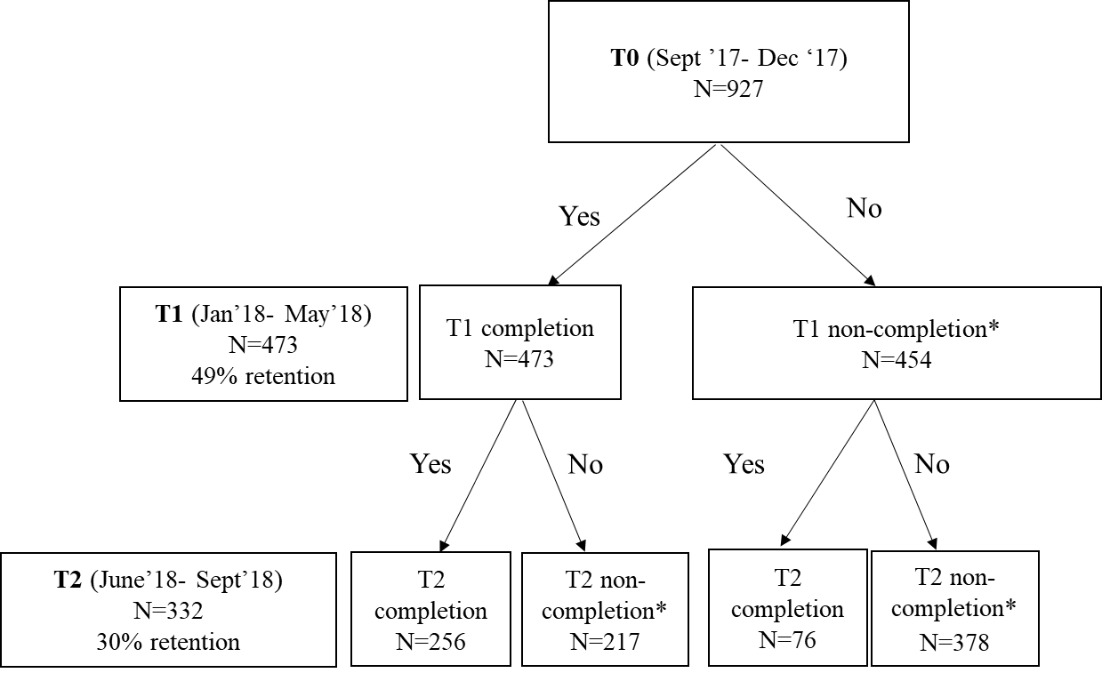
*See table 1 in manuscript for registered reasons for non-completion

