Determination of relevant sampling locations for burglary investigations.
Supplementary material

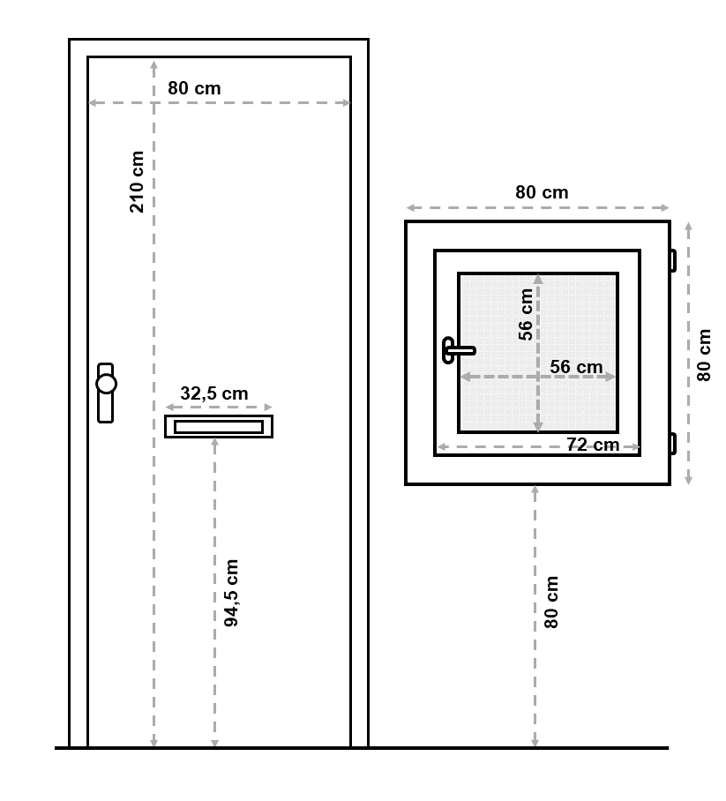
Fig. S1. Schematic overview of the experimental set-up.

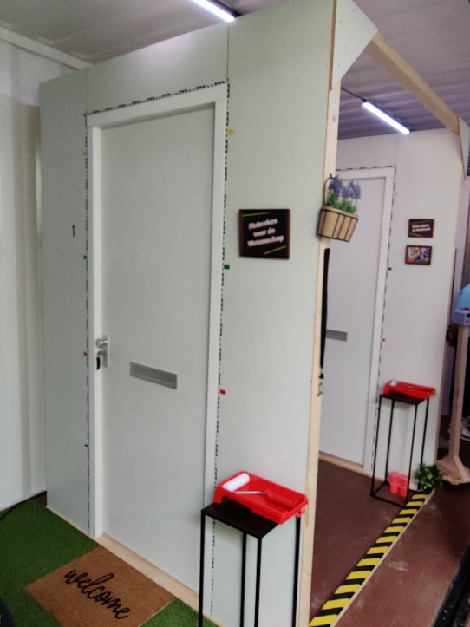
Fig. S2. Part of the experimental set-up at the Lowlands festival. Shown is the starting point of the experiment where participants receive instructions and begin with simulating the first scenario.

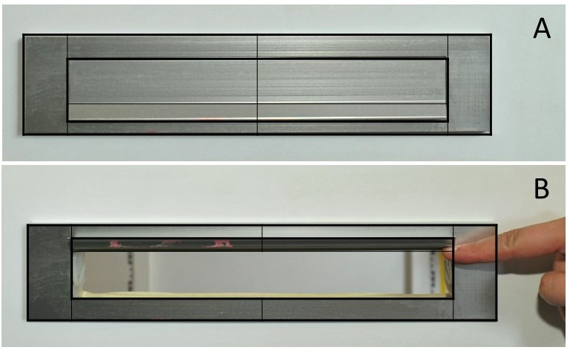
Fig. S3. Grid overlay on the mail slot. A) The mail slot in closed condition and B) the mail slot when the flap is lifted, showing the underside of the rim.

