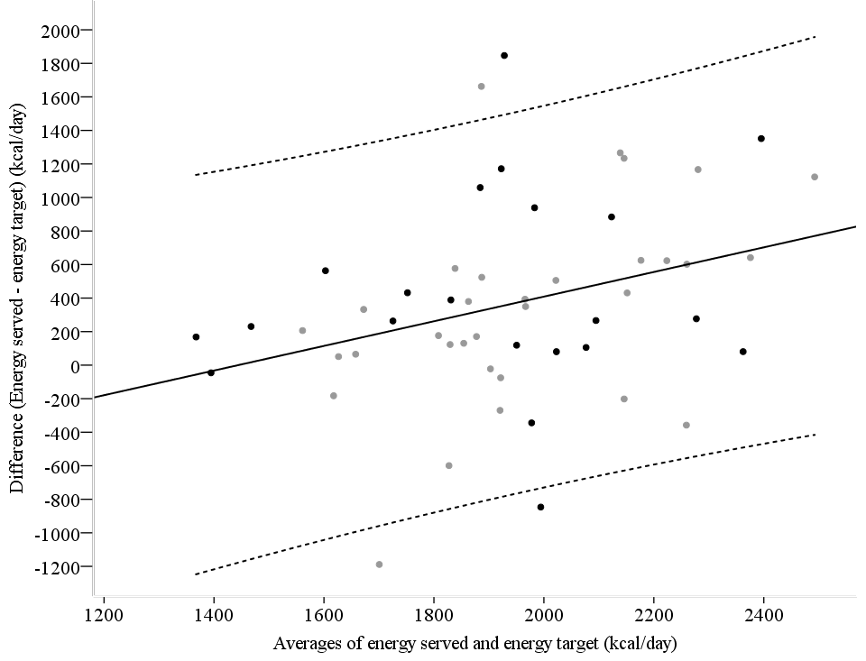
Supplementary figure 2. Bland-Altman plot of the difference versus averages of measured and estimated resting metabolic rate (RMR) in patients.
Black dots represent the indirect calorimetry group (n=22) and grey dots represent the equation group (n=31). The solid middle lines represent the mean differences in measured and estimated resting RMR, while the dashed lines at its sides represent the upper and lower 95% limit of agreement (mean difference±1.96 SD). No proportional bias was observed between the measured versus estimated RMR.

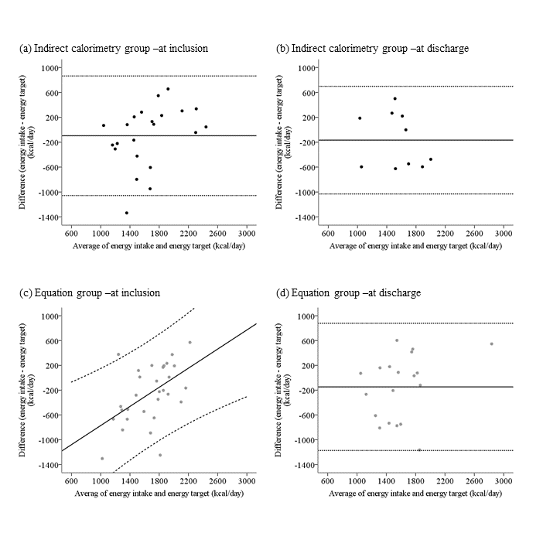
Supplementary figure 3. Bland-Altman plots of energy intake and energy target at inclusion and discharge among patients in the indirect calorimetry group (n=22 and n=10) (a, b) and the equation group (n=31 and n=19) (c, d). The solid middle lines represent the mean differences in energy intake and energy target, while the dashed lines at its sides represent the upper and lower 95% limit of agreement (mean difference±1.96 SD) (a, b, d). Proportional bias for energy intake versus target was observed at the inclusion in the equation group; the solid lines represent the expected differences in energy intake and target, while the dashed lines represent the regression-based upper and lower 95% limit of agreement (expected difference±1.96 SD) (c).
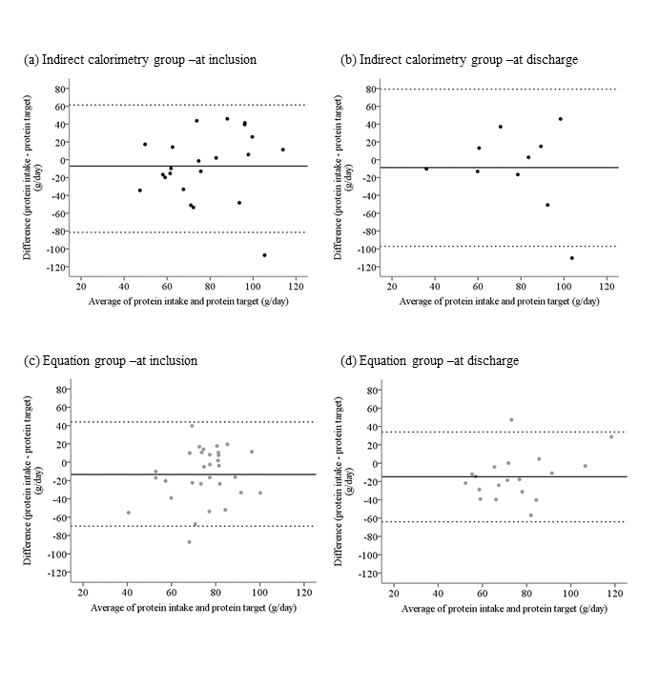
Supplementary figure 4. Bland-Altman plots of protein intake and protein target at inclusion and discharge among patients in the indirect calorimetry group (n=22 and n=10) (a, b) and the equation group (n=31 and n=19) (c, d). The solid middle lines represent the mean differences in protein intake and protein target, while the dashed lines at its sides represent the upper and lower 95% limit of agreement (mean difference±1.96 SD).

Supplementary Table 1. Energy intake and the macronutrient composition of the meal prior to RMR measurement in the indirect calorimetry and equation groups
Intake at breakfast | Indirect calorimetry group | Equation group
Energy (kcal) | 392.3 [219.2; 535.1] | 419.1 [276.0; 542.2]
% contribution by protein | 16.7 [12.2; 19.6] | 16.9 [12.4; 20.2]
% contribution by fat | 23.4 [16.5; 29.6] | 26.3 [20.2; 35.0]
% contribution by carbohydrate | 59.0 [50.6; 62.2] | 55.1 [46.1; 60.8]

