How Architecture Can Improve the Quality of Life of Individuals Showing Challenging Behaviour: A Case Study at a Dutch Very-Intensive-Care Facility

ID 980 Berit Ann Roos^{1,2}, Mark Mobach¹, and Ann Heylighen²
¹ Hanze University of Applied Sciences, The Netherlands, email: {b.a.roos|m.p.mobach}@pl.hanze.nl
² KU Leuven, Dept. of Architecture, Research[x]Design, Belgium, {ann.heylighen}@kuleuven.be

ABSTRACT
Challenging behaviour, such as aggression towards oneself, others, or objects, arises in interaction with the environment and may prevent individuals from participating in society and compromise their quality of life (QoL). Literature suggests that architects can contribute to prevention, by influencing challenging behaviour before rather than after its occurrence. By conducting a case study at a very-intensive-care facility, we explore how architecture can contribute to the QoL of intellectually impaired (and autistic) individuals showing challenging behaviour.
The case study is based on interviews with residents and care providers, and direct observations of their daily life.
Preliminary findings confirm the relevance of architecture in influencing challenging behaviour. They suggest that the residents are dependent on the (visual and auditory) connection with the care provider. Also, care providers confirm the importance of this connection for the quality of the care they provide. At the same time, residents may experience anxiety triggered by fellow residents and their challenging behaviour.
Residents may also feel stress when faced with unexpected situations and this may lead to an onset of challenging behaviour. Sensory sensitivity, specifically to noise and heat is also relevant for their QoL.
The findings will be further substantiated through multiple triangulation with available data (personal files, incident reports, photographs). Future research, specifically focused on intellectually impaired individuals showing challenging behaviour, is needed to better understand the similarities and differences between their needs and the needs of autistic people.

Keywords: architecture, autism, challenging behaviour, intellectual impairment, quality of life
Introduction
Emerson (1995) defines challenging behaviour as culturally abnormal behaviour of such intensity, frequency, or duration that the person’s or others’ physical safety is likely to be placed in serious jeopardy, or behaviour which is likely to seriously limit or deny access to the use of ordinary community services. It includes self-injury and various forms of aggression. The main reasons for showing challenging behaviour include a desire to increase social attention, escape undesirable situations, adjust levels of sensory stimulation, or increase access to preferred objects or activities (Emerson, 1995). A high percentage of intellectually impaired people showing challenging behaviour have a diagnosis on the autism spectrum (Carpenter, 2011).
According to Simó-Pinatella et al. (2013, 4582):
‘…challenging behavior is one of the largest barriers to ensuring that people with intellectual disabilities […] are able to participate in the community. These difficulties have become one of the main causes of social exclusion.’
In recent years we have seen a lively debate on suitable living environments for intellectually impaired individuals showing challenging behaviour. From an architect’s point of view this debate raises the question how architecture can contribute to creating environments that positively influence such behaviour. Although architecture cannot cure challenging behaviour, it does have impact on the occurrence of particular activities or psychological states (e.g., stress), which in turn affects such behaviour.
In the Netherlands, two cases illustrate living conditions bare of dignity, a sense of home, and choice. In 1988, images reached the media of a young woman chained naked to a wall, showing the helplessness of care providers in handling challenging behaviour. That this helplessness did not vanish became apparent in 2011: videos were published of a Dutch boy chained to the wall in a barren environment. Both persons’ quality of life (QoL) improved greatly with a change of their treatment, but also of their living environment (Van Zijl, 1999; Vriesema, 2012). In an effort to prevent individuals with challenging behaviour from escaping or becoming aggressive, towards themselves, others, or the physical environment, spaces are sometimes made vandal-proof. By that these rooms may be experienced as sterile, stripped of a sense of home, and in some cases even inhuman. Healthcare organizations tend to respond by trying to contain such behaviour through policies and procedures (Farrell, Shafiei, and Salmon, 2010), which may create a chain of risk reduction that compromises the QoL of individuals showing it:
‘Lack of control over one's [physical, interpersonal and programmatic] environment may lead to a vicious cycle of behavior. Environmental factors lead to an onset of behavior which challenges others, which in turn leads to the person's environment becoming more restrictive (less access to activities, less control etc.). This restrictive environment may in turn lead to an increase in behavior, which may lead to further environmental restrictions (Parris and Watson, 2011, 30).’
Our research is motivated by the hypothesis that, besides appropriate treatment, people’s QoL can also be enhanced by architecture. Architecture can contribute to prevention, since it affects the occurrence of particular activities or psychological states, and by doing so, influences challenging behaviour before rather than after its occurrence. With their research on evidence based design, Roger Ulrich et al. (2008) demonstrated the effect on patient outcomes of the physical environment, such as nature views and daylight. Moreover, spatial features like crowdedness, lack of privacy, or too much noise directly lead to stress (Mobach, 2009). Stress can also be triggered by an environment that causes uncertainty, lacks control, and presents too much novelty (Sternberg, 2009). In this context, the built environment is considered one of the most crucial factors influencing a person’s QoL (Health Council of the Netherlands, 2009). The World Report on Disability (WHO, 2011) recommends creating enabling environments, environments – physical, social, and attitudinal – that do not disable, but foster participation and inclusion.
An important relation exists between challenging behaviour and the environment (Carpenter, 2011; Farrell et al. 2010). Farrell et al. (2010, 1649) even state that ‘manipulating the environment (physical and cultural) clearly offers one way to reduce CB (challenging behaviour) …’ However, knowledge seems to be lacking of how the environment should be manipulated to do so. The central research question of our study is therefore: ‘How can architecture contribute to the QoL of people with an intellectual impairment, and possibly autism, showing challenging behaviour?’
Method
In addressing this research question, qualitative research was conducted with case study research at a exemplary Dutch very-intensive-care facility. This facility was specifically designed for individuals with an intellectual impairment showing challenging behaviour. Therefore this studies case is an excellent example of an extreme case, allowing us to understand the limits of existing theories and develop new concepts, variables, and theories (Flyvbjerg, 2011).
The first author is the architect of this facility. She also acted as a researcher (henceforth, ‘the researcher’) and explicitly sought to learn as a reflective practitioner (Schön, 1983). This approach enriched the data with an insider perspective of architecture and the design proces. The research was conducted with a team of professors, and a healthcare practitioner who is also the mother of a child with an intellectual impairment showing challenging behaviour.
This study was approved by the Social and Societal Ethical Committee of the KU Leuven. All names used are pseudonyms and are not in any way related to or can be traced back to respondents.
Setting
The very-intensive-care facility, in use since 2013, is located in a residential care park. Residents whose former living condition, treatment, and behaviour turned into an undesirable dead-lock, can be transferred to the facility, where they receive intensive treatment in small groups. The most stable group of four individuals with best communication skills, living there since its opening five years ago, was selected.
Data Collection
The observations, resulting in fieldnotes, and interviews took place in April/May 2018. One week, the researcher was part of residents’ daily life for observation and to conduct unstructured interviews with two members of the group, seven care providers, and the team manager, all of which was recorded. Five of the interviewed professionals are the group’s primary care providers; the others provide care to other groups but function as a stand-in, if necessary. The latter provided insight into differences and similarities with other groups.
The members of the group are:
- Lilith is a 33-year-old lady. She has a diagnosis on the autism spectrum and anxiety disorder. She shows an emotional age of 3 and verbal age of 6-11 years.
- Daniel is a 26-year-old man. He has a diagnosis on the autism spectrum and post-traumatic attachment disorder. He shows an emotional age of 0 - 18 month and a verbal age between 1,5 and 3,5 years.
- Hilde is a 40-year-old lady. She has a diagnosis on the autism spectrum and shows an emotional age of 3 and a verbal age of 7 years.
- Stefan is a young man of 18 years. He has a diagnosis on the autism spectrum. Since we didn’t receive the approval of his parents to analyse his personal files we don’t know more about his emotional or verbal age.
Since the members of the group have difficulties expressing themselves or their spatial experiences, only two of the residents were interviewed. During the interviews, a translating care provider was present, who adjusted questions to the individuals’ capacities.
All participants were informed about the study, and the fact that the researcher is also the architect of the facility, in written form and orally by the manager. All of them, or their legal guardians, gave their consent to be observed and interviewed.
Data Analysis
The transcribed interviews and fieldnotes were analysed roughly following the QUAGOL (Dierckx de Casterlé et al. 2011). The preliminary findings of the case study were also compared with related work.
The interviews and fieldnotes are in Dutch. Relevant quotes have been translated to English by the authors. The case study is still in progress; preliminary findings need to be confirmed by multiple triangulation with other data.
Findings
An initial analysis of the interviews and fieldnotes resulted in three major topics: the (visual and auditory) connection resident – care provider and resident – co-resident; the importance of predictability; and the sensory sensitivity, specifically to noise and heat.
Residents who participated in the case study seem to be dependent on the connection with the care provider. The nearness, visual or auditory, to their care providers provides them a sense of safety.
…Daniel has a very low emotional age, therefore, if you leave the room Daniel doesn’t realize that you’re in the hall. Just like a child when the mother walks away. (Care provider 1)
The participating care providers also report a need for connection to the resident in visual and auditory sense, since it allows recognizing the state (s)he is in. When the resident shows the first signs of stress, they can immediately make a connection and influence a possible onset of challenging behaviour.
…as soon as you hear the door handle move you want to look into the hallway to see who’s leaving his room. Because this has effect on the other residents in the living room. In order to be ahead of situations we need the overview. (Care provider 2)
Most residents seem to experience stress from the (challenging) behaviour of fellow residents. Their unpredictable, loud, and sometimes aggressive behaviour is frightful and also challenging given the residents’ (sensory) sensitivity.
Lilith can experience the living room as unsafe and is quite afraid of her fellow residents. She does everything to prevent certain co-residents to get too close. (Observation)
Daniel is often a target of hard objects that are thrown at him. (Care provider 1)
Individuals showing challenging behaviour may experience stress when faced with unpredictable situations, e.g. somebody entering unexpectedly, not knowing who is behind a door or around a corner. Residents seem to be supported by predictability and overview, since they see others approaching. Overview promotes also the visual connection with the care providers and enhances the residents’ sense of safety.
If you put Lilith on this couch in the middle of the living room and something happens behind her she’ll start to look behind her in sheer panic. She really wants to know what’s happening and misses the overview in that moment. (Care provider 3)
Not only unexpected situations, also unexplainable noise, e.g. the gurgling sound of a nearby bath being emptied, may cause fear and lead to an onset of challenging behaviour.
…if the bath gets emptied then the gutter goes really gghhhpt. It really scared me….I was scared shitless. (Stefan)
During the night, noises like screaming and smashing doors may lead to stress and a possible outbreak of challenging behaviour. Also the lack of control over temperature, noise, light, and smell can cause stress.
What I don’t like about this house is that we have such small windows (to open) and that my room gets so hot. (Lilith)
The unexpected shattering of dishes and screaming of a co-resident frightened Stefan in his room. He ran towards the noise, started cursing at the co-resident, and threatened to hit her. (Observation)
Several care providers stated that the transfer of sound between the apartments was often a reason for the onset of challenging behaviour at night.
It’s really about door open, door close. This noise carries through all the walls. (Care provider night watch)
During the design process it was decided that only the small and highly placed windows could be opened, because the organization was worried that residents might escape, others might enter, and that unwanted items might be exchanged.
Preliminary findings suggest that this is in line with the residents’ feeling of safety, since they tend to be afraid of somebody entering their room through the windows.
Unfortunately this choice for safety ignores the wish for influence on temperature and prevents proper cross-ventilation.
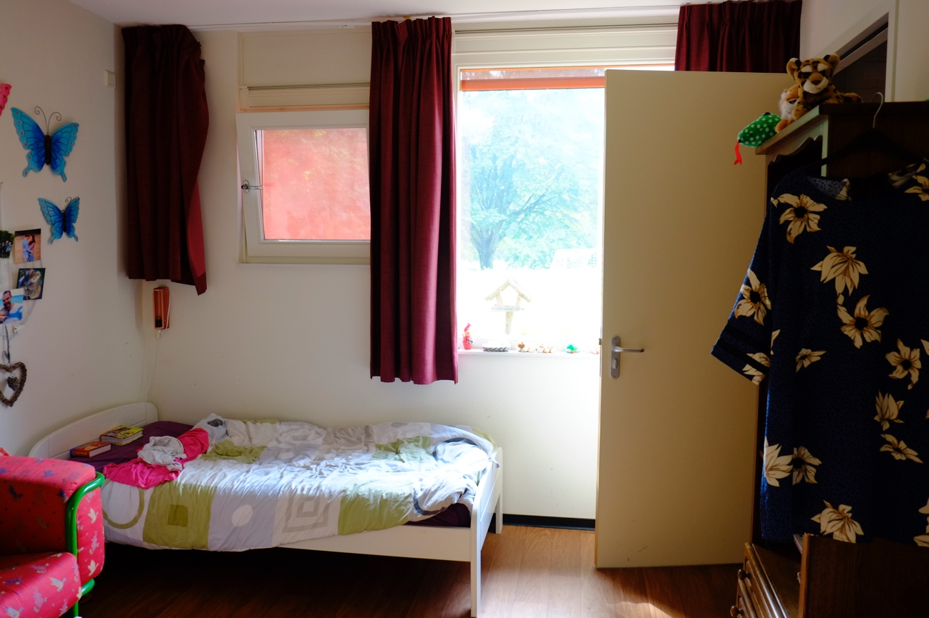
Discussion and Conclusion
These preliminary findings from the ongoing case study provide initial insights to start answering our research question: ‘How can architecture contribute to the QoL of people with an intellectual impairment, and possibly autism, showing challenging behaviour?’
Connection, in relation to overview, is one of the most frequently mentioned topics in the interviews and observed in all four residents, but seems to receive little attention in related work. Important to the group members seems to be the self-regulation of interpersonal distance; nearness to the care provider and distance from potentially frightful encounters with fellow residents,. The other topics; importance of predictability and the attention to the sensory sensitivity, are supported by previous research, specifically in sources about autism (Mostafa, 2014). This suggests that architecture which promotes sensory adjustment, e.g. possibilities to cross-ventilate and excellent acoustic measures, may improve the QoL of these residents.
Even though none of the group members are alike, our preliminary findings suggest that, regardless of their noticeable differences, they seem to share similar preferences and needs.
Limitations
Given the significant body of literature on sensory environments (Snoezelen), these might have been interesting to investigate, but these were absent in studied facility.
Possible limitations of our study are that the interviews with the residents needed a ‘translating’ care provider who might influence the answers. The fact that the researcher is the architect of the building might be seen as an advantage but also as a possible limitation, since it might involve ‘bias’ and restrain participants from being completely honest. This study uses the combination of the different perspectives (outsider/insider; practitioner/researcher; architectural design/facility management/healthcare) as a strategy to enrich the analysis, ensure its trustworthiness, and avoid bias.
One might argue that findings from a single and extreme case cannot be generalized. However, a carefully selected single case study can not only generalize findings (Flyvbjerg 2011), but also support exemplification and transferability.
Future work
To gain deeper insight into the group’s daily life, findings will be further substantiated through multiple triangulation with more available data. These include personal files, incident reports, lists of reparations, and pictures of three different walks through the building. The mix of resident-centred data sources, various methods, and investigators with different backgrounds will provide a rich and credible representation of residents’ life in the built environment.
Future research, specifically focused on intellectually impaired individuals showing challenging behaviour, is needed to better understand and confirm the relevance of our current findings. Moreover, empirical research on the similarities and differences between the needs of individuals showing challenging behaviour and those of autistic people is recommended.
References
Carpenter, P. 2011. “Autism and challenging behaviour”. In Challenging Behaviour and People with Learning Disabilities A Handbook 11 2011 (109-117) edited by S. Hardy, and T. Joyce. Brighton: Pavilion Pub.
Dierckx de Casterlé, B., Gastmans, C, Bryon, E., and Denier, Y. 2012. "QUAGOL." International Journal of Nursing Studies 49 (3): 360-371. doi:10.1016/j.ijnurstu.2011.09.012. http://dx.doi.org/10.1016/j.ijnurstu.2011.09.012.
Emerson, E. 2001. Challenging Behaviour. 2nd ed. Cambridge: Cambridge University Press. doi:10.1017/CBO9780511543739.
Farrell, G., Shafiei, T., and Salmon, P. 2010. "Facing Up to 'Challenging Behaviour'." Journal of Advanced Nursing 66 (7): 1644-1655.
Flyvbjerg, B. 2011, "Case Study," in Denzin, N. and Lincoln, Y. eds., The Sage Handbook of Qualitative Research, 4th Edition (Thousand Oaks, CA: Sage, 2011), Chapter 17, 301-316
Health Council of the Netherlands. 2009. The hospital as a healing environment. The Hague: Author.
Mobach, M. P. 2009. Een Organisatie Van Vlees En Steen. Koninklijke Van Gorcum.
Mostafa, M. 2014. "Architecture for Autism." ArchNet - IJAR: International Journal of Architectural Research 8 (1): 143-158.
Parris, A., and Watson, K. 2011. “Environmental interventions”. In Challenging Behaviour and People with Learning Disabilities A Handbook 3 2011 (29-47) edited by S. Hardy, and T. Joyce. Brighton: Pavilion Pub.
Schön, D. 1983. The Reflective Practitioner. Harper Torchbooks ; New York: Basic Books.
Simo-Pinatella, D., Font-Roura, J., Alomar-Kurz, E., Gine, C., Matson, J., and Cifre, I. 2013. "Antecedent Events as Predictive Variables for Behavioral Function." Research in Developmental Disabilities 34 (12): 4582-4590.
Sternberg, E. 2009. Healing Spaces. Cambridge, Mass: Harvard University Press.
Ulrich, R., Zimring, C., Zhu, X., DuBose, J., Seo, H., Choi, Y., Quan, X., and Joseph, J. 2008. "A Review of the Research Literature on Evidence-Based Healthcare Design." Herd 1 (3): 61-125. doi:10.1177/193758670800100306.
Van Zijl, F. 1999. “Foto Jolanda Venema leidde tot omslag in zwakzinnigenzorg.” De Volkskrant, July 23. https://www.volkskrant.nl/wetenschap/foto-jolanda-venema-leidde-tot-omslag-in-zwakzinnigenzorg~a520595
Vriesema, I. 2012. “In Sliedrecht is hij blij: Daar zit hij niet vast.” NRC, January 4. https://www.nrc.nl/nieuws/2012/01/04/in-sliedrecht-is-hij-blij-daar-zit-hij-niet-vast-12147502-a993874
WHO. 2011. World report on disability. Geneva: Author.

